Name___________________________________ Period_________ Date_________

Animal Digestion Notes

Objective A: Describe the major parts and functions of the digestive system

The Process:

- The mouth is the starting point that begins the _______________________ process.

- The tongue is used for: _______________________ the food,

___________________________, and ___________________________.

- The teeth _________________ and __________________ the feed into smaller particles

that may be ____________________________________.

2 Types of Digestion:

- Physical:

- Chemical:

In the mouth
- _________________________ __________________ excrete saliva, which serves many purposes.
-Water to moisten
-Mucin to lubricate
-Bicarbonates to buffer acids
-Enzyme amylase to break down carbs.

The esophagus
is the __________________________ _________________________ tube that leads from the ________________ to the opening of the _____________________________
What type of muscles make up the esophagus?

The Stomach
is a hollow muscle that _______________________ and _______________________ to _______________________ digestive juices with the food causing it to ______________________
The Small Intestine
is next and is controlled by a ______________________________ muscle that helps move food _________________and through the tract.
- The small intestine is made up of three segments:
- __________________________________
- __________________________________
- __________________________________
Duodenum:
- First segment
- Uses _________________________ from the pancreas and intestinal wall to break down ____________________, __________________, and ________________.
Jejunum & Ileum
- Where ____________________________________ takes place.
- Absorption passes_________________________ from the ___________________________ to the ___________________________.
The walls of the Jejunum & Ileum
Villi
- Small _____________________________
- Increase _____________________ for absorption
- Absorb nutrients through membranes known as ________________________.
- These membranes allow particles to pass through in a process called ____________________.

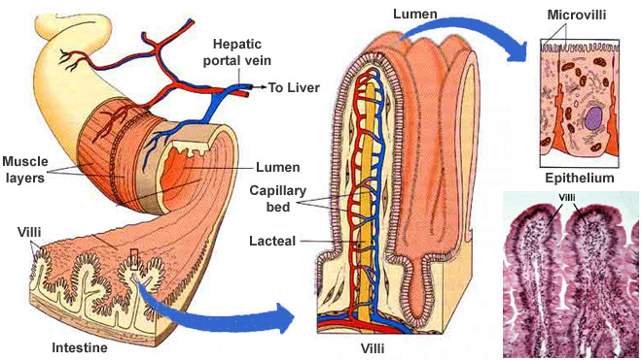
The Large Intestine
Is the last organ of the digestive tract. It contains two segments:
- Cecum is where _____________________ food such as hay and grass is broken down into ____________________ nutrients.
- Colon provides a _________________________ ________________ for waste from the digestive process, and is the ________________________ part of the large intestine.

Rectum
is the _____________________ end of the large intestine and the __________________ digestive system.

Objective B: Define monogastric and list characteristics of monogastric animals

Monogastric =
Characteristics of Monogastrics:
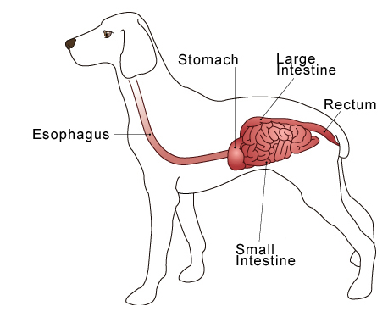 1-
2-

Objective C: Describe the Ruminant Digestive System

Ruminant Systems:

1-

2-

3-

4-
1-Rumen
-Serves as a storage vat where food is soaked, mixed, and fermented by bacteria.

-Contains fingerlike projections called ____________________________ that absorb nutrients through the rumen wall to provide energy.

2-Reticulum
-2nd Compartment
-Contains _____________________ and ___________________________ to promote fermentation.
-Food is ingested, then _________________________, chewed, and ___________________ again.
**Eructed means:

-Nicknames for reticulum=

-What is “Hardware Disease?”

Reticular Groove:
Why?

3-Omasum
-A round organ with wall that contain many ___________________ or “plies”
- Lined with blunt muscular papillae that grind roughage.
4-Abomasum
-This compartment is the only true glandular stomach of the ruminant.
-Secretes______________________________ to digest microbes.
Characteristics of Ruminants:
1-
2-
3-

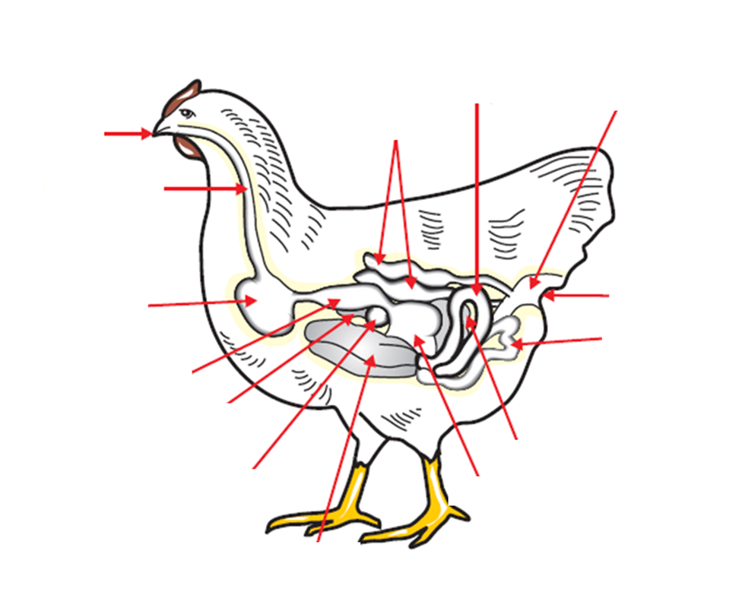D. Describe the Avian Digestive System

Avian Digestion:
- Mouth:
- Esophagus: (Same Function as other animals)
- Crop:
  - Factoid:
- Proventriculus
- Gizzard
- Small Intestine: (Same Function as other animals)
- Ceca: (Same Function as other animals)
- Large Intestine: (Same Function as other animals)
- Cloaca
E. Classify Animals according to their type of digestion
 | Monogastric | Ruminant | Modified Monogastric | Avian
Type of Food  Consumed |  |  |  | Characteristics:
# of Stomach Compartments

Classify animals:
 | What do they eat? | How many stomach compartments | Type of Digestive System
Cattle
Horses
Sheep
Chickens
Rabbits
Goats
Pigs
Turkeys

F. List digestive enzymes and their function
Enzyme:

In the Mouth
Saliva: Begins the breakdown of carbs
In the stomach
Gastric Juice:
-0.2-0.5% hydrochloric acid
-Produced by stomach/abomasum
Pepsin:
-Breaks down proteins
In the small intestine
-Chyme: An acid
-Pancreatic Juices
-Trypsin: Breaks down protein
-Pancreatic Amylase: changes starch to a simple sugar
-Bile: Green liquid produced in the liver and stored in gall bladder. Digests fat.

