Name____________________________________ Period_________ Date__________

Animal Breeding & Reproduction Notes

- Discuss the meaning and importance of reproduction in animal agriculture

- Producers rely on successfully reproducing young for ________________________

  - Cow/Calf Operation without calves?
  - Hog farm without piglets?
  - Sheep farm without lambs?
  - Dairy farm without calves?

- Our ______________________ would be in jeopardy without sound animal reproductive practices

- Describe benefits of using genetically superior animals for breeding

- Responsible Animal Breeding:
  - Only breed animals with ______________________________ to be passed on

    - Natural selection would eliminate most genetic problems, but artificial selection does not
    - It is our responsibility to be responsible animal breeders

- _______________________________
    - Hybrid Vigor
    - Eliminate poor characteristics
    - Improve efficiency of food production

- Define common terms and describe the function of reproductive organs

Terminology:

- __________________________- carrying a fetus
- __________________________-the union of the EGG and SPERM nuclei
- __________________________-occurrence of fertilization
- __________________________-release of an ovule from the female.
- __________________________-The time from fertilization or conception of a female until she gives birth
Ovaries:

-Egg or Ovule- Female Reproductive Cell

7- Testes:

-Sperm: Male cell or gamete
-Semen: Fluid that carries sperm

Female:

_____________________ - opening of reproductive tract
_____________________ - channel for birth and copulation
_____________________ - divides vagina and uterus
_____________________ - Where fetus grows and receives nourishment
_____________________- where fetus grows
_____________________- where fertilization occurs
_____________________ – produces eggs and hormones

Male:

_____________________ – produce sperm and testosterone
_____________________ – collects and stores sperm
_____________________– transports sperm
_____________________ – places sperm in female
_____________________-
_____________________- produce semen
_____________________-
_____________________- protects testes & maintains temp.
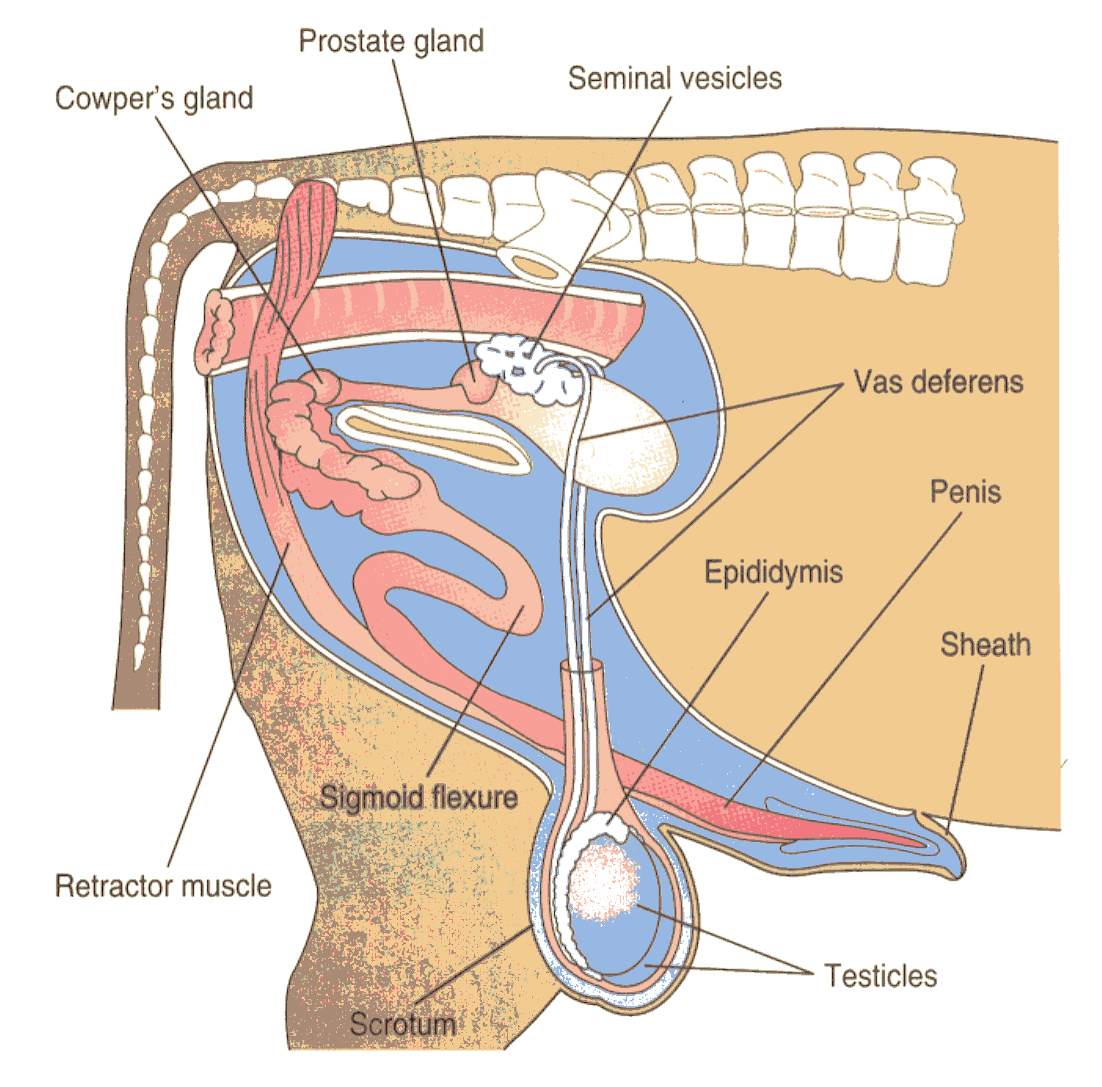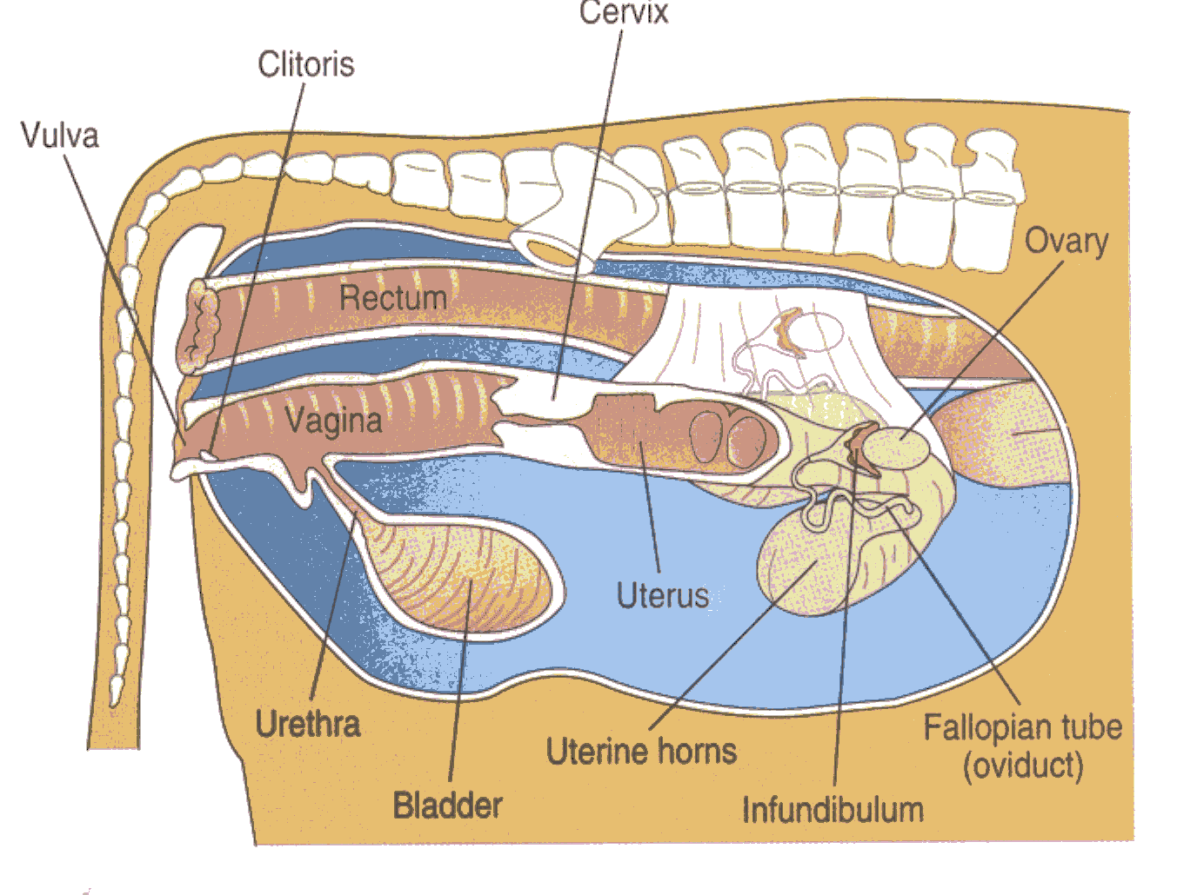_____________________- opening of reproductive tract

- Compare estrous cycles and gestation of different species and list common signs of breeding readiness

- _________________________

  - Time between periods of estrus, or “heat”
  - Often influenced by of hours of light in the day

Estrous Cycles by Species:

Species | Estrous Cycle | Length of Estrus (heat) | Ovulation
Cow |  | 12-18 hours |  | 10-14 hours after estrus
Mare |  | 6-8 days |  | 1-2 days before estrus ends
Doe (goat) |  | 30-40 hours |  | At end of estrus
Doe (rabbit) |  | Constant |  | 8-10 hours after mating
Sow |  | 40-72 hours |  | Mid estrus
Ewe |  | 24-36 hours |  | Late estrus
Dog |  | 9 days |  | 1-2 days after estrus begins
Cat |  | 5 days |  | 24 after mating

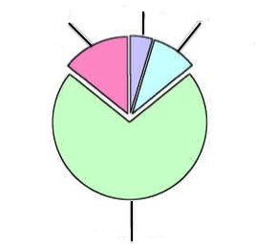1- _____________________________- also known as “heat.” The period of time when female is receptive to male and conception can occur.
-Hormone: Estrogen

2- _____________________________- follows estrus. Usually when ovulation occurs
-Hormone: LH (leutenizing hormone)

3- _____________________________- Period of cycle when system assumes pregnancy.
-Hormone: Progesterone

4- _____________________________- If not pregnant, body prepares to begin cycle again
-Hormone: Progesterone drops

Signs of Breeding Readiness:

- Standing to be mounted or trailing other cattle  - Clear, viscous mucous from vulva  - Swelling of vulva  - Restlessness | - Restlessness whinnying  - Frequent urination in small amounts  - Backing up and pushing on fences or other objects
- Erect ears  - Moist vulva  - Standing or “Locked up Response” when touched | - Seeking out and standing for ram  (symptoms are much less noticeable than other species)
- None  - Sperm from a rooster can be viable in a hen for up to 30 days. Once inseminated, it’s stored until the next egg is produced | - None  - Does ovulate at presence of sperm, not on a cycle

Gestation:
- Length of ______________________________
- Begins with ____________________________ and ends with parturition (birth).
Species | Gestation | Breeding Season | Cycle
Cattle

Sheep & Goats

Swine

Horse

Rabbit

Chickens

- All animals have different gestation lengths. Usually the LARGER the animal, the LONGER the gestation.

- Describe signs of parturition and dystocia

Parturition-

Signs:
  - Milk develops in udder
  - Abdomen drops
  - Nesting
  - Restlessness or pacing
  - Abdomen muscles contract (watch for young!)

Stage 1: Preparatory Stage (Labor

Stage 2: Delivery of Fetus

Stage 3: Expulsion of the placenta

Stage 4: Period of rest

Dystocia:

Causes:
-Presentation (position fetus is coming out)
-Oversized fetus
-Multiple births
-Exhaustion, uterine contractions stop

Solutions: Call a vet or assist yourself
-Cesarean Section (C-Section)
- Assist manually

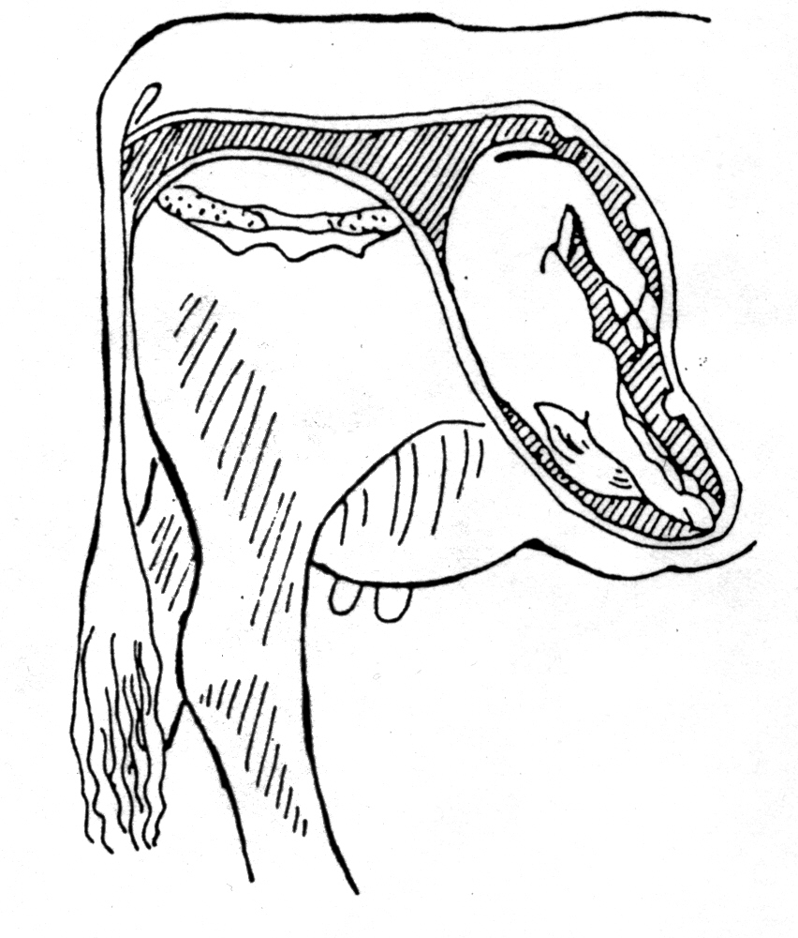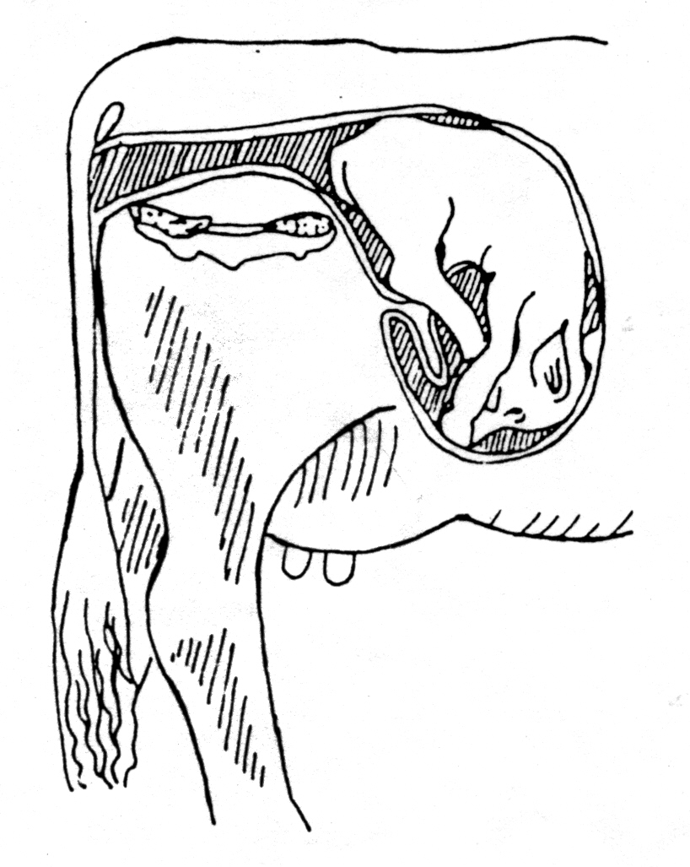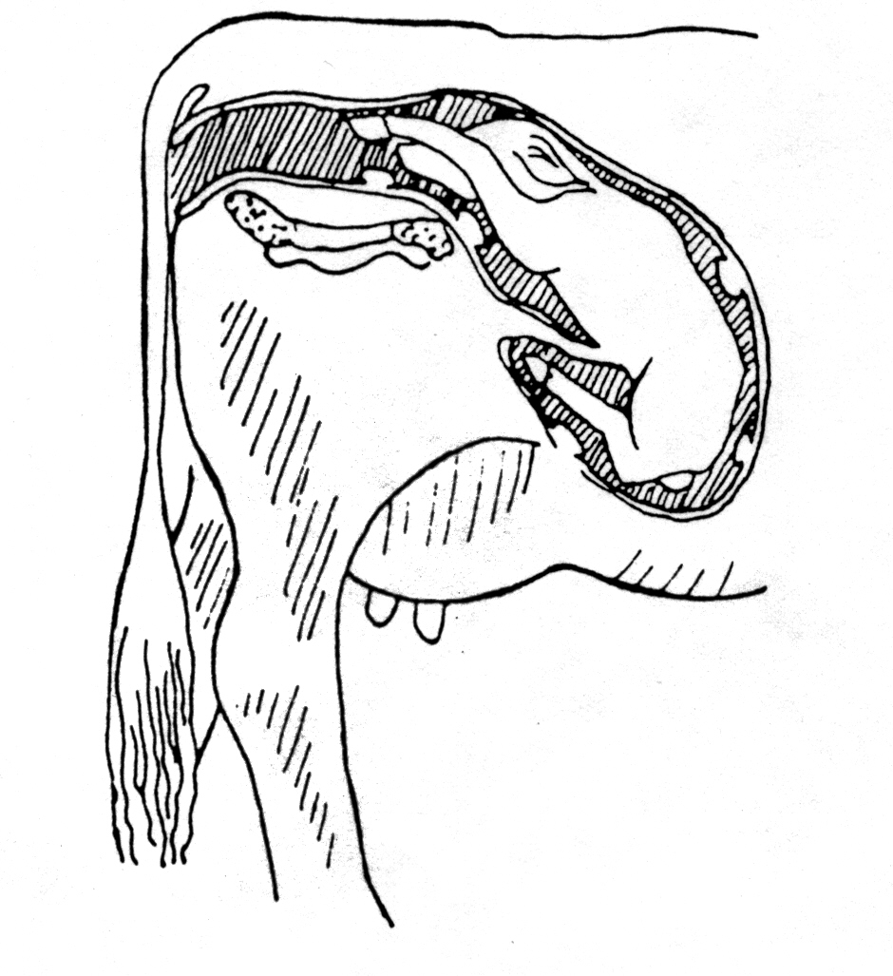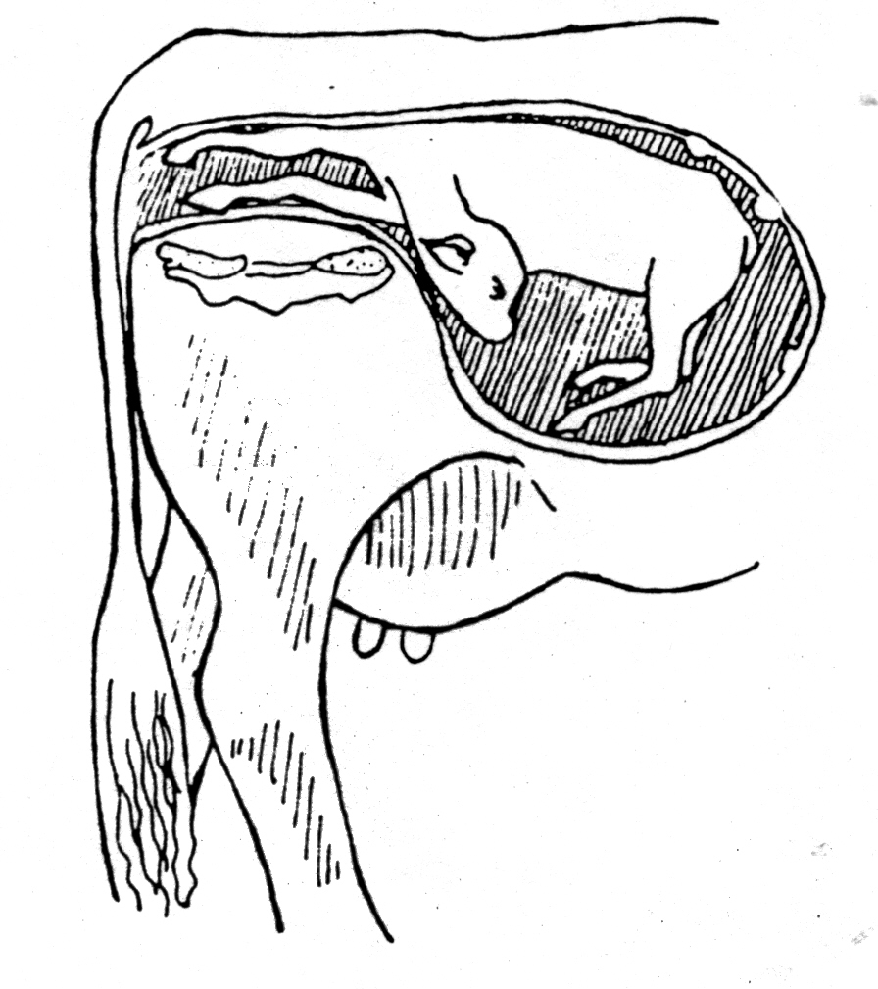
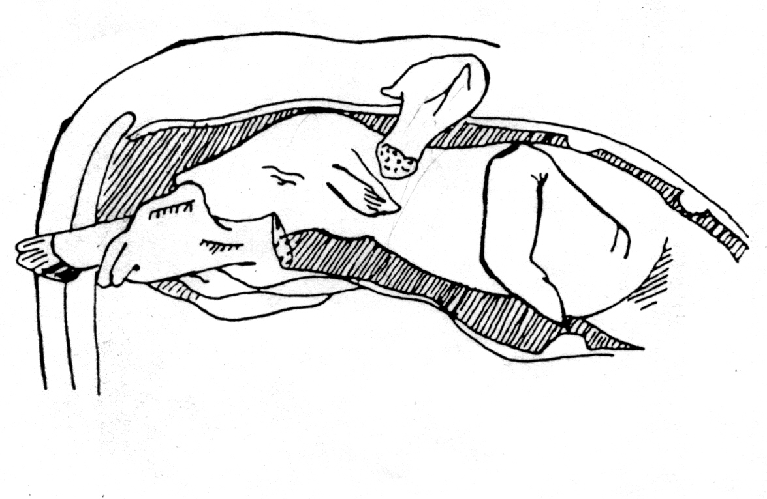

- Describe the purpose and benefits of reproductive technologies

Reproductive Technology:

1- ________________________________

Collecting and placing sperm from the male to the female reproductive tract without natural mating

Step 1: Collect & Store Semen
-Collect Semen
-Extend sample and place in straws
-Store in liquid nitrogen

Step 2: Manually inject semen into female reproductive tract at correct stage of estrus

Advantages of Artificial Insemination:
1- Wider selection & use of outstanding sires
2- Rapid Genetic and herd improvement
3- Overcome physical barriers to mating
    - Examples: Aggressive behavior or injuries
4- Danger of the bull is eliminated
5- Eliminate cost of purchasing and keeping a bull

Disadvantages of Artificial Insemination:
1- Skilled Technician or training required
2-Very close supervision of females is necessary to accurately determine stage of estrus

2- ________________________________

The process of causing a herd of cows or heifers to come into estrus and ovulate at or near the same time

3- ________________________________

The transfer of fertilized egg(s) from a donor female to one or more recipient females. Utilizes genetics of superior FEMALES by producing more offspring per year than by natural breeding methods

4- ________________________________
Producing an EXACT genetic copy of an organism

