Name___________________________________ Period_________ Date_________

Animal Anatomy & Physiology Notes

- Describe the role of the muscular and skeletal system

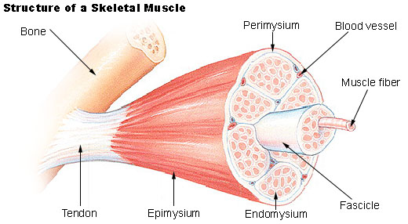
Muscular System:
Function & Purpose:

System is made up of:

Muscle Contraction:
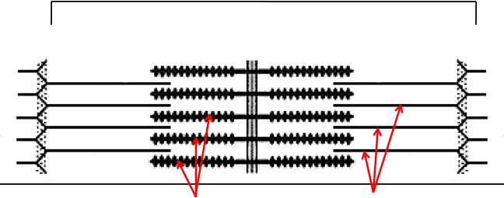
- Distance between Z bands shorten

- Thin filaments slide past thick filaments

3 Types of Muscle:

Skeletal
- __________________ portion of muscle
- Moves the __________________
- Attached to bones with __________________
- VOLUNTARY muscles
Smooth
- Controls movement of ________________________
  - Peristalsis of digestive system, urinary system, etc

- INVOLUNTARY muscles

Cardiac
- Makes up the__________________

- INVOLUNTARY muscles
Skeletal System

Function & Purpose:

System is made up of:

Cartilage
- _________________________ that isn’t as hard as bone and is somewhat flexible
  - Nose & Ears

Long Bones
- __________________ bones in body

- Provides _________________________for animal to stand and move

Short Bones
- Are often as big ________________ as they are ________________.

- Mostly found in _____________________ and give flexibility

Irregular Bones
- Are irregularly shaped

- Function as _________________ & ____________________.
  - Vertebrae

    - Cervical Vertebrae = Neck
    - Thoracic Vertebrae = Rib cage
    - Lumbar Vertebrae = Lower back
    - Sacral Vertebrae = Pelvic (hip) area
    - Coccygeal = From pelvis to end of tail

Flat Bones
- Relatively _________________ and flat

- Usually multiple flat bones ___________________ together

- Usually help _______________organs
  - Ribs & skull

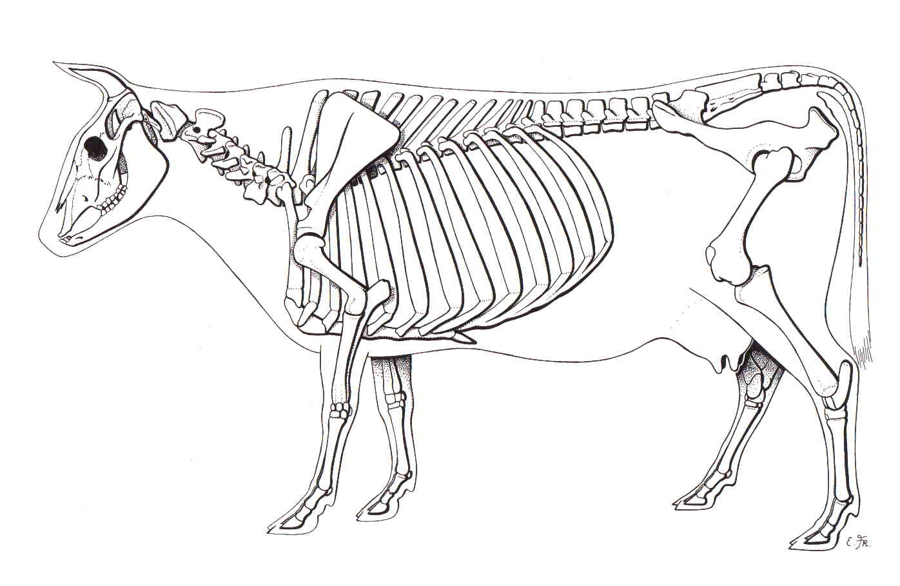

Joints
- Connections of ________________ in the animal’s body

- Held together with ______________________

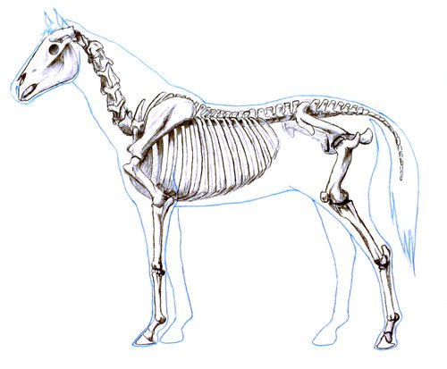
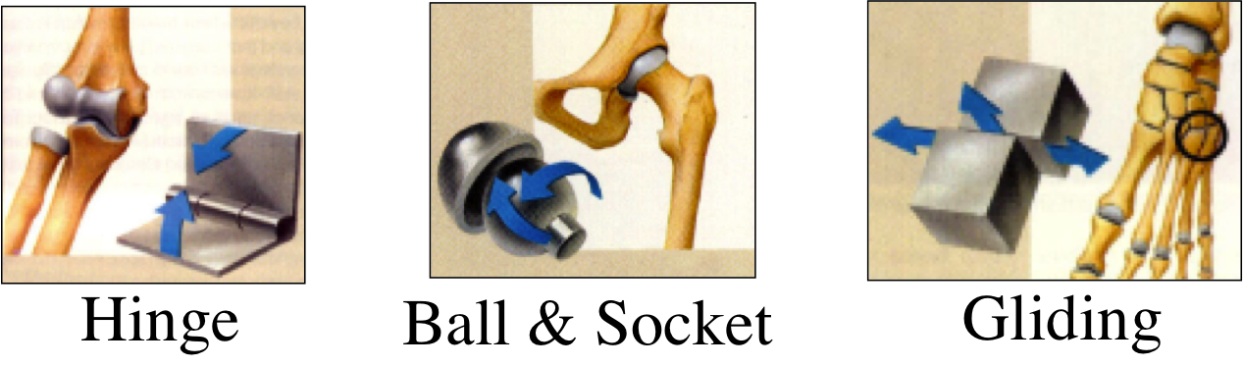

- Describe the role of the respiratory & circulatory system

Respiratory System

Function & Purpose:

System is made up of:

1. Nostrils
    - Also called __________________
    - Paired, external openings
      - Separated by nasal septum
    - Dilatable
      - Species Differences
        - Horse: Very Pliable and Dilatable
        - Pig: Rigid

2. Nasal Cavities

  - Separated by Nasal Septum, and from mouth by palate

3. Pharynx

4. Larynx
  - "_____________________________"
  - Organ of phonation (Sound Production)
  - Passing air causes vibration of _______________________.
Syrinx
      - Voice Box for Birds

5. Trachea
    - Primary passage way to __________________________
    - Cartilage Rings prevent ______________________ of airway

6. Bronchi
  - 2 main branches from trachea

7. Bronchioles
  - Smaller stems of _________________

8. Alveoli
  - Principle site of gaseous diffusion between_____________ and _________________

Lungs
  - Principle Organ of Respiratory System

  - Paired, found in Thorax
    - a. Thorax expansion causes Lung expansion

Circulatory System

Function & Purpose:

System is made up of:

- Closed __________________ pathway

- Blood cells follow this path over, and over, and over again
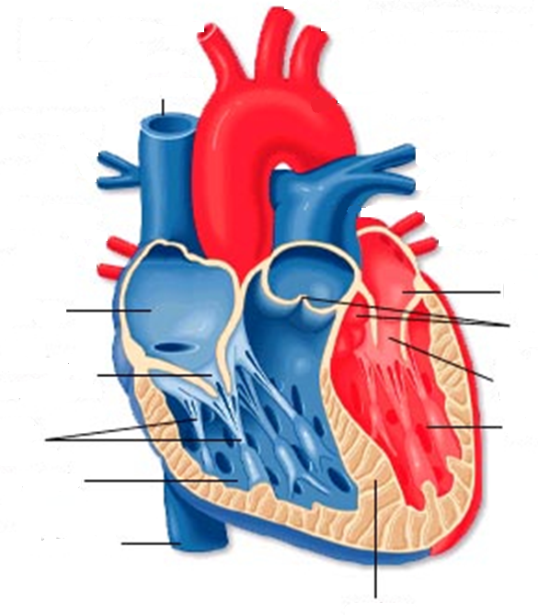

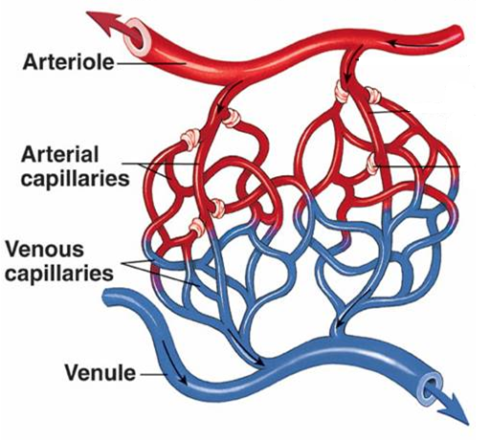
Follow the flow of blood through the circulatory system:

- Capillary

- Thin walled blood vessels
- Site of gas exchange
- Microscopic in size
- Every inch of your body is covered in hundreds of capillaries

- Vein

- Superior/Inferior Vena Cava

- Right Atrium

- Tricuspid Valve

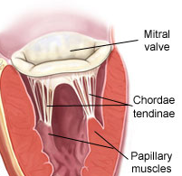

- Purkinje Fibers

Purkinje Fibers

- Right Ventricle

- Semilunar Valve

- Lungs
  - Blood is oxygenated by lungs
  - Oxygen exchange takes place by passing from the alveoli (respiratory system) to the capillaries (circulatory system)

- Left Atrium
- Mitral Valve

- Left Ventricle
- Last (4th) chamber of the heart before blood leaves the heart through arteries

- Arteries

- LARGE blood passageways that take OXYGENATED blood AWAY from the heart

- (Capillaries) (start the path all over again)
  - Here is where the process starts all over
  - Junction between arteries and veins

- Describe the role of the nervous system

Nervous System

Function & Purpose:

System is made up of:

Brain

  - __________________center of the nervous system

Nerves

  - Long, fiber like structures that send _______________________ from the body to the brain

Spinal Cord

  - Long bundle of nervous tissue extending from the ______________to the lumbar __________________.

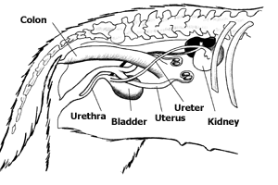
- Describe the role of the excretory system

Excretory System

Function & Purpose:

System is made up of:

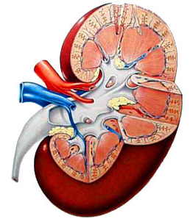
Kidneys
- Each animal has __________
- Filters _________________ from blood
- Toxins are excreted as __________________.

Ureters
- Each animal has 2
- Tube carrying urine from _______________ to __________________.

Bladder
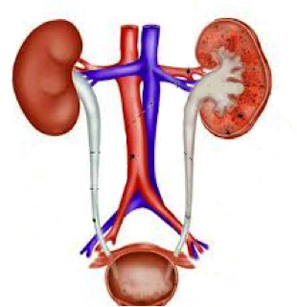
- Each animal has 1
- Stores _________________ til it is excreted

Urethra
- Each animal has 1
- Passageway from bladder for urine to exit the body

