Name___________________________________ Period_________ Date_________

Dairy Products & Processing Notes

- List the nutritional benefits dairy products provide to our diets
What are the benefits of eating yogurt?
How does milk compare to other drinks?

What are the benefits of eating cheese?
How can milk & milk products help you lose weight?

Why Dairy Products
What 9 essential nutrients do milk products provide?
Why should athletes consume chocolate milk?

How much calcium do YOU need? How many servings?
In addition to building bones, what diseases does calcium help prevent?

- Breakdown the components found in milk
Components of Milk:

- Describe how fluid milk is graded and processed
1- Milk is stored in refrigerated tank until milk truck picks it up
2- Milk is delivered to a milk processing plant
3- Clarification:

4- Separation:

5- Standardization:
- Whole Milk- No less than 3.25% milk fat
- Reduced Fat- 2% milk fat
- Low fat- 1.0% milk fat
- Skim/Non Fat – less than .5% milk fat

6- Pasteurization:

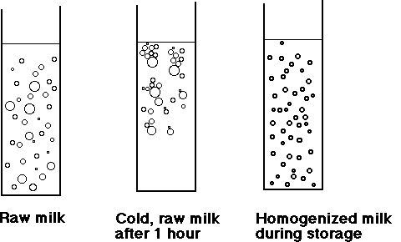
7- Homogenization:

8- Fortification:

  - Vitamin D is added to 98% of fluid milk in the U.S.
  - Vitamin A is added to all reduced fat, lowfat and skim/nonfat/fat free milk.
- Describe the process of making other dairy products such as cheese, butter, ice cream, etc

- Some products are not actually made with milk. They are imitation dairy products
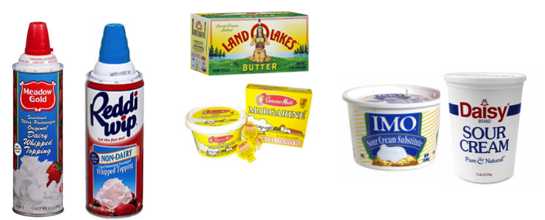

- Real dairy products have the seal

- “Milk” will be one of the first ingredients

