Name__________________________________ Period_______ Date____________

Genetics
in the Animal Industry Notes

- Describe the role and importance of genetics in the animal industry

__________________________

  - “Survival of the Fittest”
  - If the animal has characteristics to survive, it reproduces
  - No human intervention

__________________________

- Humans control which animals reproduce based on presence of desirable characteristics

Why use artificial selection in agriculture?

- More ability to control and perpetuate desired characteristics
- Agricultural products are higher quality and more consistent

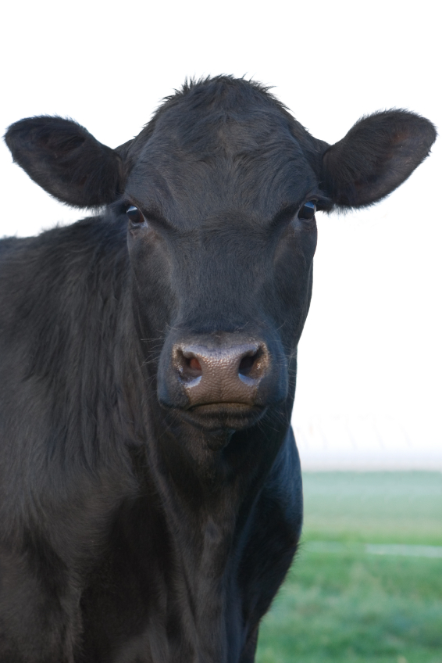
Phenotype: Genotype:

Phenotype = Genotype =

- Recognize & describe the interrelationship between genetics and the environment

- Heredity= the _____________________ an animal has to show specific traits or performance due to it’s genetic information

- Environment= The __________________ conditions that affect the traits and performance of an animal

+
=
Traits
&
Performance
(Phenotype)

- Some traits are influenced more by _________________________

- Other traits are influenced most by genetics _________________________

- ________________________= The percentage a trait is affected by the animal’s GENETIC information

  - A heritability factor of 0.0 = ____________ influence from genetics
  - A heritability factor of 1.0= ____________ influence from genetics

Cattle
Fertility = 0.10
Birth Weight = 0.45
Conformation = 0.30 - 0.38
Weaning Weight = 0.24
Height = 0.88 - 0.95
Dressing Percentage = 0.45
Ribeye Area = 0.70

Sheep
Multiple Births = 0.15
Lamb Growth Rate = 0.30
Wool Face Cover = 0.56
Wool Staple Length = 0.47
Loineye area = 0.53
Carcass Fat = .57

Swine
Piglets Farrowed = 0.10
Growth Rate= 0.30
Backfat Thickness = 0.50
Loineye area = 0.50
Length = 0.60
Chilled carcass weight = 0.60

- Identify common characteristics used to select high quality breeding stock

  - Examples: Meat production, Temperament, Coat Color, etc.

  - In the pet industry, these animals are sterilized (spayed or neutered)
  - In the livestock industry, they are usually raised for terminal markets
Beef Cattle
Dairy Cattle

Horses
Dogs
Pigs
Sheep

D. Describe and predict how traits are inherited using the punnet square

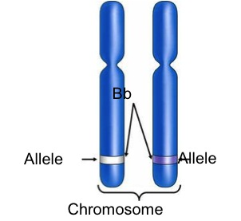
  - A form of a gene found in pairs
  - Located on chromosomes
  - 1 allele inherited from each parent
  - Represented by a letter

  - Represented by CAPITOL letters
  - This trait is the one expressed

  - Represented by lower case letters
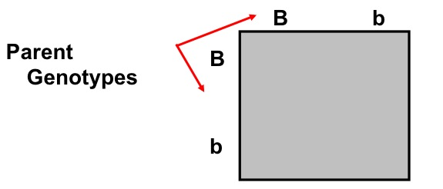
  - Only expressed if both alleles are recessive

  - Both alleles are the SAME
    - (BB) = Homozygous dominant
    - (bb) = Homozygous Recessive

  - Different alleles for the same trait
    - (Bb)

  - A method of calculating the chances of inheriting a specific trait

Now you try…
Holstein Cattle
- Black & white

- Red & White

FYI…
- Punnet squares can only be used with simple traits inherited by dominance
- The inheritance of other traits are more complex

- Compare and contrast qualitative vs. quantitative animal traits

  - Controlled by a SINGLE pair of genes
  - Can usually be observed visually (phenotypes)
    - Examples:

  - Controlled by SEVERAL pair of genes
  - Can usually be measured

F. Use EPD’s to select quality sires

E__________________ P__________________D__________________

- Indicates the genetic value of a specific sire compared to the average genetic value of it’s breed.
- Expressed as a number
- Used in the cattle industry

Calculate an EPD:
- The average maternal milk production for Herefords is 25 lbs
- The average milk production for a bull’s daughters is 21 lbs
- The maternal milk EPD for this bull is:

Common EPD’s: Beef Cattle
- CED:
- BW:
- WW:
- YW:
- CW:
- RE:
Common EPD’s: Dairy Cattle
- MILK:
- Protein:
- Fat:
- CE:
- SCS:

Benefits of using EPD’s

- Use sire’s who are _________________________________________________
  - Sires with EPD’s have likely already produced 100 or more calves
  - Pinpoint characteristics you want to improve in your herd

G. Compare common breeding systems used in the animal industry

- Breeding systems are designed based upon:

    - Financial Goals
    - Specific markets you produce for
      - Terminal markets (meat)
      - Seedstock Markets
      - Show & Purebred industry markets

Breeding Systems:

  - All animals are registered purebreds
    - Goal: Produce high quality animals to use as breeding and/or show stock

  - Breeding females are not purebred or registered
  - Sires are typically higher quality purebreds
    - Goal: Produce offspring of higher quality than the commercial female. (Sometimes called “Grading up”)

Breeding Strategies

  - Mating animals of DIFFERENT breeds
    - Goal: Increase Hybrid Vigor in hopes that offspring will inherit the good traits of both parents

  - Mating closely related animals
  - Necessary to create new breeds or isolate genes for specific traits

  - Mating related animals
    - Half siblings
    - Grandsire x granddaughter (skip generation)
*Minor form of inbreeding, but not as extreme

