lName____________________________________ Period_______ Date_____________

Introduction to
Animal Science Notes

A. List 4 functions of domestic animals

1-Food
-
-
-
-

2- Clothing
-
-
-
-

3- Power
-
-
-

4-Recreation & companionship
-
-
-
-

5- Service
-
-
-
-

B. Describe and define what considers an animal to be domesticated

Requirements for animals to be “domesticated”

- The animal is ________________ and has a _______________________.
- The animal’s ______________________ is subject to human control.
- The animal’s _______________________ depends upon humans.
- The animal’s _________________________ (psychology) is changed in domestication.
- ____________________ characteristics have appeared which occur rarely if at all in the wild.

Wild animal – Exists without human ___________________________ of any type (feeding, breeding selection, shelter, etc)

Domestic animal – _________________________________ for food & shelter, bred through artificial selection to choose and perpetuate desired traits.

Tame wild animal – a wild animal that has adapted _________________ to be useful to humans.

Feral animal – a ___________________________ animal that has returned to the wild.

C. Define common terminology used in animal science
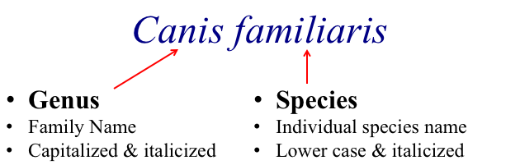

 | Genus/ Species | Baby | Young Male | Young Female | Castrated Male | Mature Male | Mature Female | Group
European Cattle
(Bovine)
Indian Cattle
(Bovine)
Sheep
(Ovine)
Pigs
(Supine)
Goats
(Caprine)
Horses
(Equine)
Chickens

Rabbits
Dogs
(Canine)
Cats
(Feline)
What is binomial nomenclature?

D. Categorize & distinguish animals by breeds, species, and types

- Species: A group of closely related animals that can _________________________ and produce
___________________ offspring.

- Breed: Animals of common ___________________ with characteristics that distinguish them from other groups within the same ________________________.

- Type: Animals of the same _______________________ that are grouped together based on the ___________________________ they produce.

Each species of livestock has specific breeds that perform best for each purpose:
- ___________________________: Produce meat efficiently
- ___________________________: Produce milk efficiently
- ___________________________:Produce meat & milk efficiently
- ___________________________:Don’t produce milk or meat efficiently, chosen for beauty
- ___________________________:Chosen for performance traits

E. List major types & uses of each species of livestock

Cattle

Sheep

Swine

Goats

Chickens

Horses

F. List & describe benefits of animal based agriculture
- Animals can convert feed that humans CAN’T eat to food humans CAN eat
- Helps maintain fertility of the land
- Personal satisfaction of working with domesticated animals
- May more fully utilize capital, machinery, and wasteland (range)
- Food Value:
- Animal Proteins are superior to vegetable proteins for humans
- Animal proteins have improved amino acid balance over vegetable protein
- Milk- Approximately 90% of milk for human consumption in the world comes from cattle
- Over 85% of the world population desires food of animal origin.

