Name________________________________ Period______ Date___________

Animal Nutrition & Feeding Notes

- List essential nutrients & their function

- Needed for growth and repair  - Helps form MUSCLES, internal organs, skin, hair, wool, feathers, hoofs and horns | - ENERGY  - The largest portion of the food supply  - Includes sugars, starch, and cellulose | - STORED Energy  - Insulation & Protection
- Organic substance  - CAN be broken down  - Needed in small quantities | - Naturally occurring  - Inorganic substance  - Can’t be broken down further  - Needed in small quantities  - Necessary for:  -Building bones  -Growth  -Overall Health | - Animal’s body is made up of 70% water  - Necessary for proper organ function  - Vital to sustaining life

Are all animal’s dietary requirements equal?

- Identify factors effecting nutrition requirements in animals

Maintenance  - No loss or gain of weight  - Known as Basal Maintenance Requirement  - 50% of animals diet is used for maintenance | Growth  - Extra energy required to grow bones, support organ systems, develop muscle, etc.  - Need high levels of fats and carbohydrates
Work  - Extra energy required to grow bones, support organ systems, develop muscle, etc.  - Need high levels of fats and carbohydrates | Gestation & Lactation  - Pregnancy requires higher levels of nutrition and energy intake  (Especially at the end of pregnancy when the fetus is growing rapidly)  - Milk production requires even more energy  (Especially calcium, phosphorus, protein)
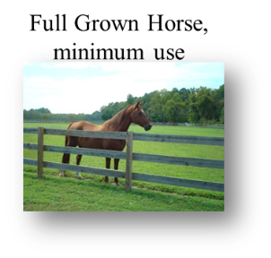
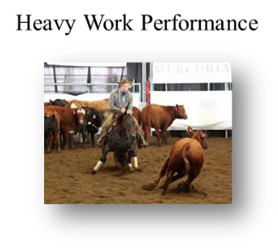
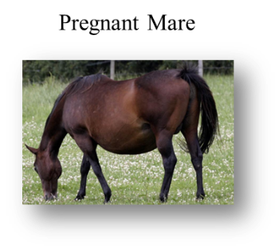
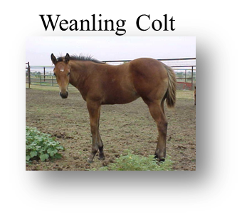
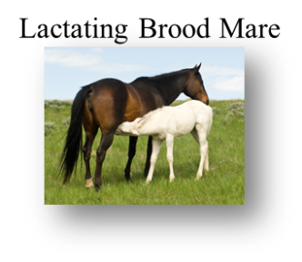
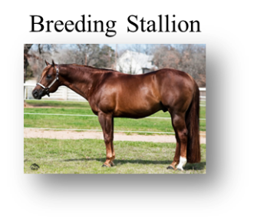

- Classify feed types and list examples and characteristics

There are 3 types of feed:
1-
2-
3-
 | Roughage | Concentrates | Supplements
Definition:
Examples:

D. Compare & contrast common feeds according to species, age, and energy requirements

Things to consider:

1-

- Premixed feeds are formulated specifically for the nutrient requirements of each species
- Type of digestive system determines which feeds an animal can digest
  - Ruminants can digest roughages
  - Monogastrics cannot break down roughage

2-

- Young, Adult, Senior?

3-

- Lactating/Gestation
- Heavy Work

- Interpret a feed label

Feed Labels:

  - Lists nutrients contained in feed
  - Lists minimum % of each nutrient

- ___________________ listed

- Usually have some feeding instructions

F. Balance a ration

How to balance a ration:

- Ration =

- Successful ration must:

  - Taste Good
  - Provide required _________________________
  - Be the cost effective
    - A few hints:
      - Rations vary by species and energy requirement
      - Some rations mix roughage, concentrates, and supplements
      - Some rations meet all dietary requirements with 1 feed

Pearson Square:

Step #1: Label ________________ names & _______

Step #2: Transfer feed name ___________________ across

Step #3: Fill in desired ____________ %

Step #4: Find absolute value of feed _______ and desired CP

Step #5: Find absolute value of feed _______ and desired CP

Step #6: Determine total _____________________.

To mix a ration using Corn & Cotton Seed Meal Use:
_____ parts Corn
_____ parts Cotton Seed Meal
_____ Total Parts

Step #7: Translate _________________ to ___________________.

100 lbs / _____ total parts =

Step #8: Determine pounds of ___________feed
____ parts Corn
____ x ____= _________Pounds Corn
____ parts Cotton Seed Meal
____ x ____= ________Pounds Cotton Seed Meal

Your Turn…
A 1400-pound cow in the second trimester of pregnancy needs 8% protein.
She is fed grass hay (6% protein) and soybean meal (49% protein)
Calculate how many pounds of each feed is required to mix a 100 pound ration of feed with 8% protein

