Name___________________________________ Period_________ Date_________

Companion, Recreation, & Therapy Animals Notes

- Identify the benefits provided by companion animals

Companion Animals Production Animals
- -
- -

- Describe the role of specialty & exotic pets in the animal industry
Exotic Animals =

*There are exotic pets and exotic livestock
*Exotic animals are illegal in many states & cities

Exotic Pet Laws =

    - Some animals are legal with a license

    - Its more likely for an exotic animal to become unwanted. If it was released, it might cause problems

Specialty =

*Most anything except dogs, cats, horses, sheep, goats, cattle, pigs, etc.

Specialty Pet Laws=
- Laws governing ownership of these animals _____________________________________________
- Provide more people the opportunity to have animals
  - Big yard or animal property isn’t necessary to own a ferret, guinea pig, or other small pet
  - Many specialty pet owners enjoy having a unique pet

How do specialty & exotic animals effect the animal industry?

1-

Exotic animals in zoos provide educational opportunities most people would never experience if animals were only in the wild

2-

The exotic animal industry provides many jobs to care for the animals in specialty zoos and exhibits as well as educate the public.

3-

Some specialty animal owners wouldn’t or can’t own a typical dog, cat, or livestock animal. Specialty animals provide more opportunities for people to experience the benefits of pet ownership.

- Compare & contrast the use of animals in recreational activities

- Rec-re-a-tion (noun):

What kind of animals are used for recreation?

- Describe the use of animals in service & therapy programs
Service Animals:
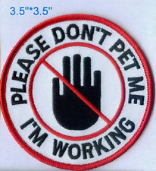

  - Guide Dogs For Blind
  - Police Dogs
  - Medical Alert Dogs
    - Seizures & diabetes
  - Search Dogs
*These animals are trained with a specific role and purpose. They should not be pet by strangers and people passing by.
    - Avalanches, natural disasters, bombings

Therapy Animals:

  - Physical Therapy
    - Animal bond helps patients heal after accidents and illness
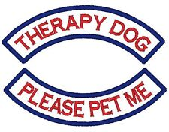
  - Psychotherapy (mental health)
    - Troubled youth
    - ADHD
    - Autism
    - Prisons
*These animals are trained to be highly sociable and can usually be pet by strangers and people passing by.

