Name______________________________________________ Period__________ Date______________

Plant Propagation
Environmental Factors of Seed Germination Lab

In this lab experiment you will be attempting to germinate seeds in various environmental situations. You will be able to identify ideal conditions for seed germination and growth and identify the recognizable symptoms of poor seed germinating conditions.

Directions:
- Split into groups as directed by your instructor
- Plant 1 flat of seeds precisely following the instructions given below
- Label your flat with the treatment number and the treatment (Example: #1: Normal Temperature)
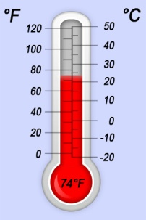
- Observe each treatment every day and fill out the observation table. Watch carefully for signs of seed germination and plant health.

Temperature Effects on Germination

#1 Normal Temperature
This seed flat will be placed in the greenhouse at normal growing temperatures

Number of seeds planted | # of days til germination | Germination Rate  (% of seeds germinated) | Observation of seedling health: Record information such as abnormal color, stem strength or weakness, legginess, height, etc

#2 Bottom Heat
This seed flat will be placed in the greenhouse on a heated greenhouse bench

Number of seeds planted | # of days til germination | Germination Rate  (% of seeds germinated) | Observation of seedling health: Record information such as abnormal color, stem strength or weakness, legginess, height, etc

#3 Cold
This seed flat will be placed in the cooler

Number of seeds planted | # of days til germination  (first day seedling breaks through soil surface) | Observation of seedling health: Record information such as abnormal color, stem strength or weakness, legginess, height, etc

#4 Excessive Heat
This seed flat will be placed in an excessively warm area

Number of seeds planted | # of days til germination | Germination Rate  (% of seeds germinated) | Observation of seedling health: Record information such as abnormal color, stem strength or weakness, legginess, height, etc
Moisture Effects on Germination and Seedling Growth

#5 No Moisture
This flat will be never be watered

Number of seeds planted | # of days til germination | Germination Rate  (% of seeds germinated) | Observation of seedling health: Record information such as abnormal color, stem strength or weakness, legginess, height, etc

#6 Regular Moisture
This flat will be watered as recommended

Number of seeds planted | # of days til germination | Germination Rate  (% of seeds germinated) | Observation of seedling health: Record information such as abnormal color, stem strength or weakness, legginess, height, etc

Flat # 7 Over-watering
This flat will be over watered

Number of seeds planted | # of days til germination | Germination Rate  (% of seeds germinated) | Observation of seedling health: Record information such as abnormal color, stem strength or weakness, legginess, height, etc

Light Effects on Germination and Seedling Growth

#8 Normal Production Light
This flat will be placed in the greenhouse with normal outdoor light

Number of seeds planted | # of days til germination | Germination Rate  (% of seeds germinated) | Observation of seedling health: Record information such as abnormal color, stem strength or weakness, legginess, height, etc

Flat #9 Normal Indoor Light
This flat will be placed in the classroom with normal indoor light

Number of seeds planted | # of days til germination | Germination Rate  (% of seeds germinated) | Observation of seedling health: Record information such as abnormal color, stem strength or weakness, legginess, height, etc

Flat #10 Dark-No Light
This flat will be placed with no light

Number of seeds planted | # of days til germination | Germination Rate  (% of seeds germinated) | Observation of seedling health: Record information such as abnormal color, stem strength or weakness, legginess, height, etc
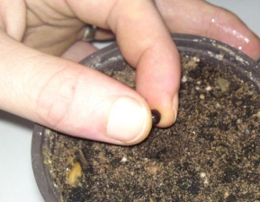
Effects of Planting Depth on Germination

Flat #11 Normal Planting Depth
Seeds will be planted at recommended planting depths

Number of seeds planted | # of days til germination | Germination Rate  (% of seeds germinated) | Observation of seedling health: Record information such as abnormal color, stem strength or weakness, legginess, height, etc

Flat #12 in Bottom of Pot
Place all seeds at the bottom of each pot

Number of seeds planted | # of days til germination | Germination Rate  (% of seeds germinated) | Observation of seedling health: Record information such as abnormal color, stem strength or weakness, legginess, height, etc

Summary: Write a 3 paragraph essay about the results of the experiment

