Name____________________________________ Period________ Date__________

Ruminant Digestive System Dissection

Directions: As you watch the dissection of a ruminant digestive system, fill in the following information for each section of the digestive system.

- Esophagus
  - Length/Size:
  - Describe Appearance:
  - Function: Connects the _______________________ to the _____________________.
- Rumen
  - Size:
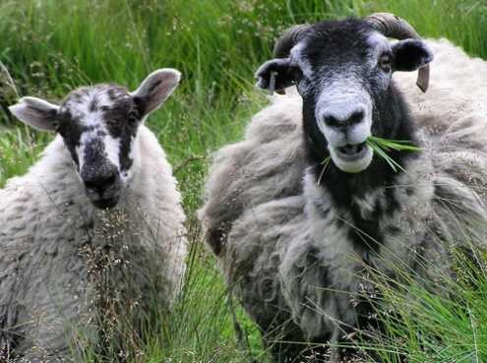
  - Describe Appearance/Texture:
  - Function:
  - Appearance of feedstuff
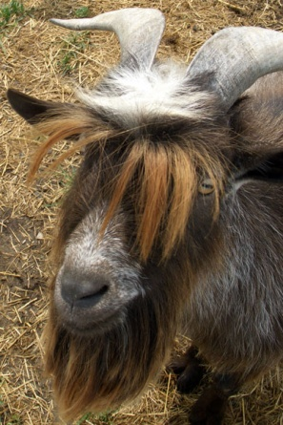
- Reticulum
  - Size:
  - Describe Appearance/Texture:
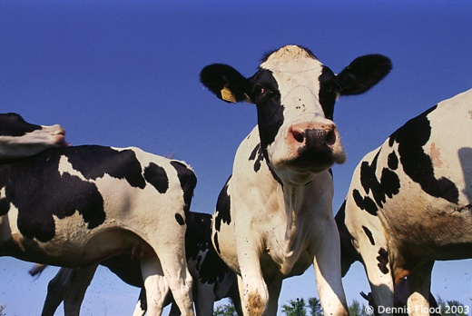
  - Function:
  - Appearance of feedstuff
- Esophagus & Mouth for remastication
- Omasum
  - Size:
  - Describe Appearance:
  - Function:
  - Appearance of feedstuff
- Abomasum
  - Size:
  - Describe Appearance:
  - Function:
  - Appearance of feedstuff
- Small Intestine/Large Intestine
  - Size:
  - Describe Appearance:
  - Function:
  - Appearance of feedstuff

