Name____________________________________ Period________ Date__________

Avian Digestive System Dissection

Directions: As you watch the dissection of an avian digestive system, fill in the following information for each section of the digestive system.

- Mouth
- Esophagus
  - Length/Size:
  - Describe Appearance:
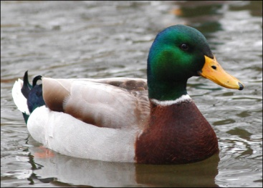
  - Function:
  - Appearance of feedstuff
- Crop
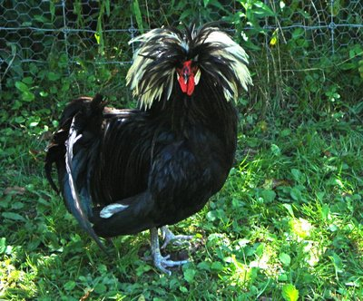
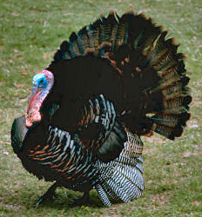
  - Length/Size:
  - Describe Appearance:
  - Function:
  - Appearance of feedstuff
- Proventriculus
  - Length/Size:
  - Describe Appearance:
  - Function:
  - Appearance of feedstuff
- Gizzard
  - Length/Size:
  - Describe Appearance:
  - Function:
  - Appearance of feedstuff

- Small Intestine
  - Length/Size:
  - Describe Appearance:
  - Function:
  - Appearance of feedstuff

- Ceca
  - Length/Size:
  - Describe Appearance:
  - Function:
  - Appearance of feedstuff

- Large Intestine
  - Length/Size:
  - Describe Appearance:
  - Function:
  - Appearance of feedstuff
- Cloaca

