Name_________________________________ Period________ Date_________

Comparing Dog & Cat Foods

Directions: Follow the directions below to compare the following dog and cat foods.

Dog Food vs Cat Food
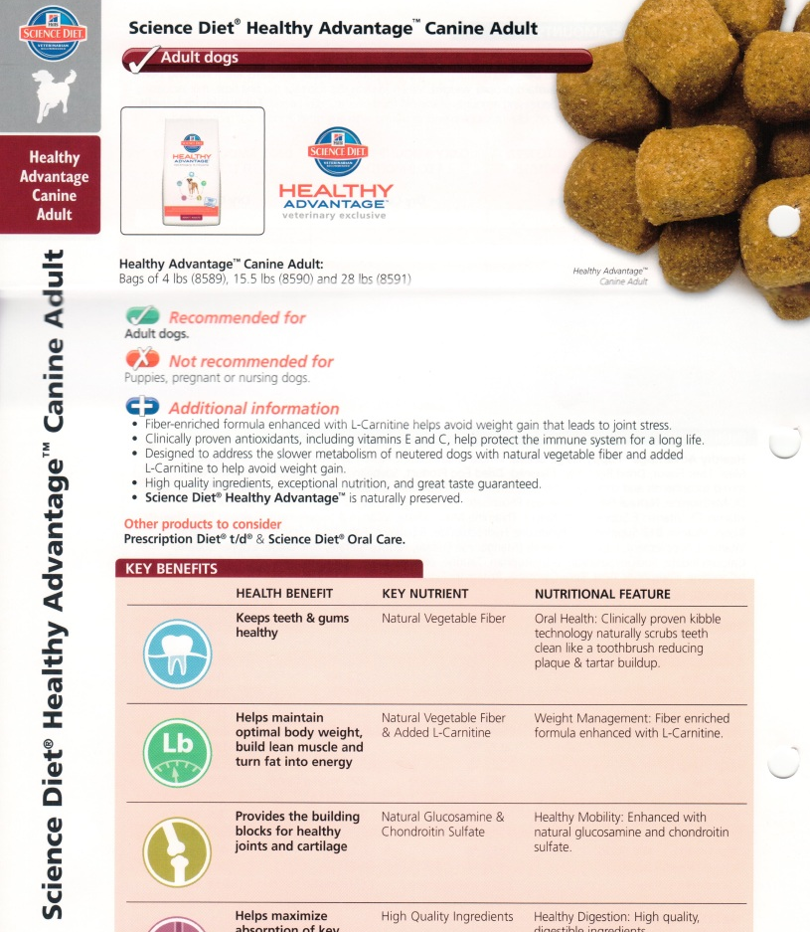
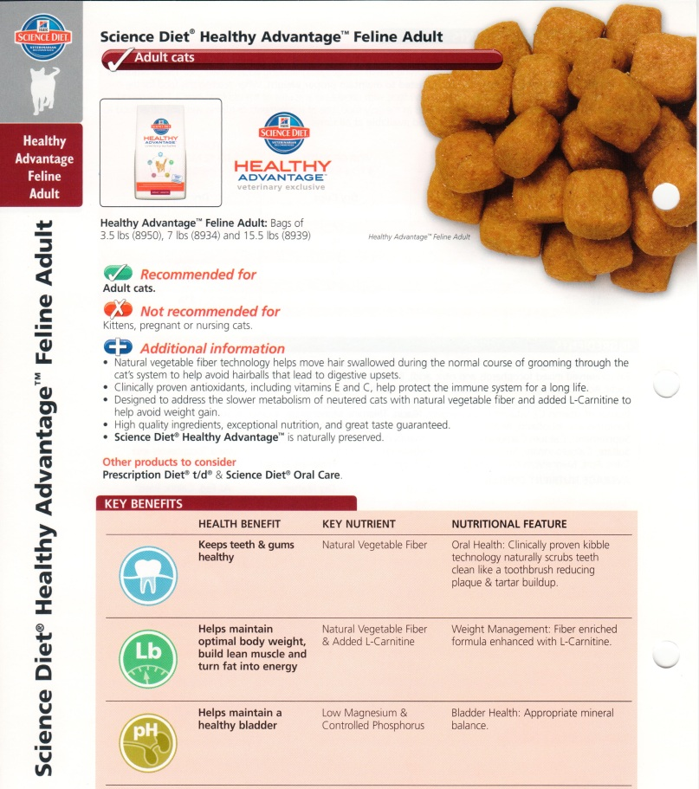

- Which feed has more protein?
  - Cat= _____ %
  - Dog=_____ %

- Which feed has more fat?
  - Cat= _____ %
  - Dog=_____ %

- Which feed has more carbohydrates?
  - Cat= _____ %
  - Dog=_____ %

- Highlight all of the ingredients in both feeds that are from an animal source

- Based on the ingredients listed in this food, are dogs:
  - Omnivores
  - Carnivores

- Based on the ingredients listed in this food, are cats:
  - Omnivores
  - Carnivores

Puppy vs Large Breed Puppy

- Which feed has more protein?
  - Puppy= _____ %
  - Large Breed=_____ %

- Which feed has more fat?
  - Puppy = _____ %
  - Large Breed =_____ %

- Which feed has more carbohydrates?
  - Puppy = _____ %
  - Large Breed =_____ %

- Highlight all of the ingredients in both feeds that are from a plant source

- Highlight the total calories found in each feed

- List 3 major differences between Adult dog food (pg 1) and puppy food.

Adult vs High energy Adult

- Which feed has more protein?
  - Adult= _____ %
  - High Energy=_____ %

- Which feed has more fat?
  - Adult = _____ %
  - High Energy =_____ %

- Which feed has more carbohydrates?
  - Adult = _____ %
  - High Energy =_____ %

- How many calories per kilogram of feed are in the ‘High Energy’ blend?

- Highlight the ingredients in the ‘High Energy’ blend that are vitamins or minerals.

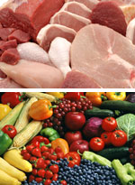
Carnivore or omnivore?
Dogs are classified as members of the family Canidae and the order Carnivora, but this does not necessarily translate to behavior, anatomy or feeding preferences.
Judge for yourself
Some animals may look like carnivores or act like carnivores. But, are they really true carnivores? You be the judge.
-Wolves attack plant-eating animals, but one of the first parts they consume is the stomach contents and the viscera of those animals.¹
-Coyotes eat a variety of foodstuffs including small mammals, amphibians, birds, fruits and herbivore feces.
-Panda bears are also members of the order Carnivora, but they are herbivores who primarily consume bamboo leaves.

Key points
The term "opportunivore" may best describe the dog's natural desire to eat whatever is available — plants as well as animals.
Strict or true carnivores, such as cats, have a higher nutritional requirement for taurine (an amino acid), arachidonic acid (a fatty acid), and certain vitamins (niacin, pyridoxine, vitamin A), which are readily available in animal protein and fat sources.
Omnivores, such as dogs and people, don't have higher requirements for taurine and certain vitamins and can create their own arachidonic acid from vegetable oils.
Omnivore qualities
There are other nutritional, behavioral and physical factors that separate the omnivore and carnivore worlds:
-Dogs have teeth (molars) with relatively flat surfaces designed to grind up bones as well as fibrous plant material.
-Dogs can digest almost 100% of the carbohydrates they consume.²
-Dogs have a small intestine that occupies about 23 percent of the total gastrointestinal volume, which is consistent with other omnivores; the small intestine of cats occupies only 15 percent.^{3,4}
-Dogs can create vitamin A from betacarotene found in plants.

Confusion in their conclusion
Some folks have come to the erroneous conclusion that dogs must be carnivores because they fall under the order Carnivora. A close look at the anatomy, behavior and feeding preferences of dogs shows that they are actually omnivorous — able to eat and remain healthy with both animal and plant foodstuffs.

