Name____________________________________ Period________ Date__________
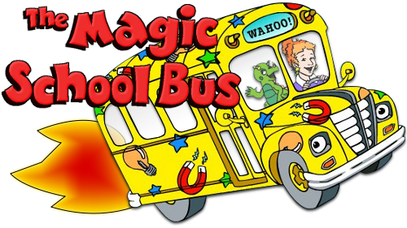

Magic School Bus Digestive System Tour

Directions: In this assignment you are going to imagine that you are substituting for “Miss Frizzle” and taking her class on a tour of each of the digestive systems you have learned about. Remember that Miss Frizzle was a very descriptive tour guide. Take the Magic School Bus and describe every organ you will pass through (in correct order) along with everything you will see as you go through the digestive systems.

Field Trip #1: Monogastric Digestive System

The Magic School Bus is going to follow “Carlos” the corn kernel as it passes through Petunia the pig…

Field Trip #2: Ruminant Digestive System

The Magic School Bus is going to follow “Harry” the hay bale as it passes through Bessie the cow…

Field Trip #3: Avian Digestive System

The Magic School Bus is going to follow “Carla” the corn kernel as it passes through Rocky the Rooster…

