2-liter hydroponics

Objective
Create a simple hydroponic system that can be built with supplies found in most High School Agriculture classrooms. There are many types of hydroponic systems. One of the simplest is the wick design presented in this activity.
Purpose
Hydroponics is a method of growing plants in water without soil. Hydroponics are a great way to show plant development in mediums other than soil. Hydroponics is where a large amount of our tomatoes, cucumbers, and lettuce come from in the grocery store (Google EuroFresh farms or look them up on YouTube).
Supplies
- 2 liter bottle w/cap
- Nutrient solution (if you intend on growing the plants to full fruiting maturity)
- Paper towels (cheaper the better)
- Permanent marker
- Ruler
- Scissors
- X-acto knife
- Seeds (ones I have tried are listed below)
  - Beans (garden bean): fast germination
  - Soybean: slow germination
- Soilless/Hydroponic medium (ones I have tried are listed below)
  - Sand: did not work well, seeds rotted because the medium was always saturated
  - Pearlite: works great
  - Vermiculite: work great
  - Peat moss: needs to be saturated BEFORE putting into the apparatus
  - Sawdust: doesn’t work well by itself, but will germinate
  - Straw: if it is finely chopped (cut with scissors) it works well
  - Potting mix (peat moss/pearlite): works great

Methods
- Remove all labels from the 2 liter bottle.
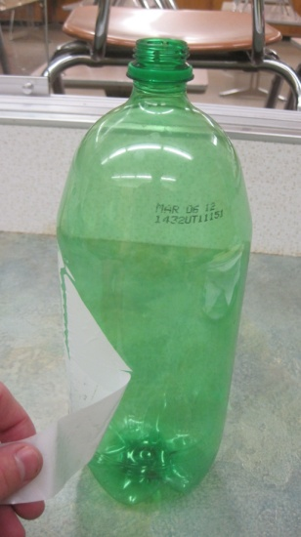

- Place the bottle on a flat surface and measure 7 inches up from the bottom of the bottle and make a mark with a permanent marker.
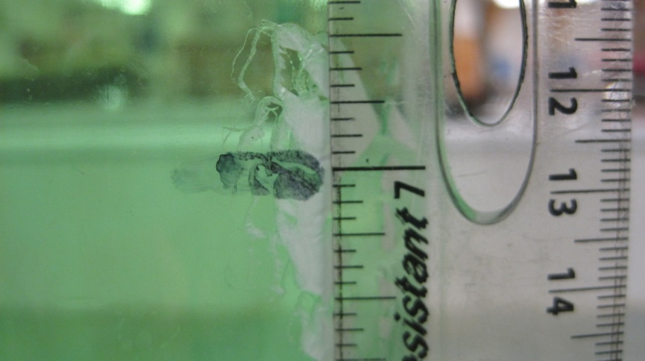

- Repeat step 2 until there are marks around the entire bottle about 1” (one inch) apart from each other.
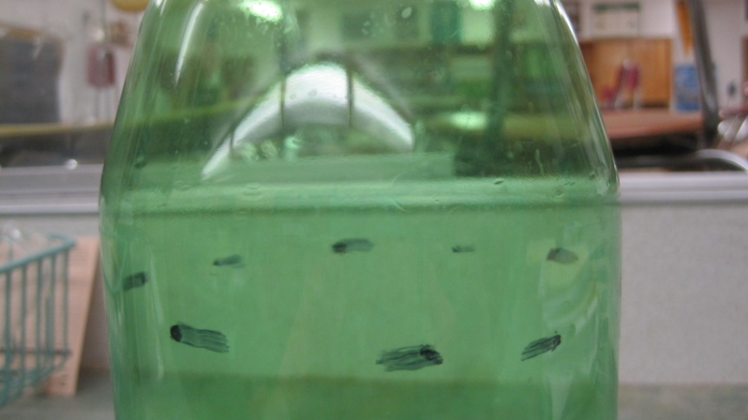
- Put the cap on the bottle and place it on a flat surface.
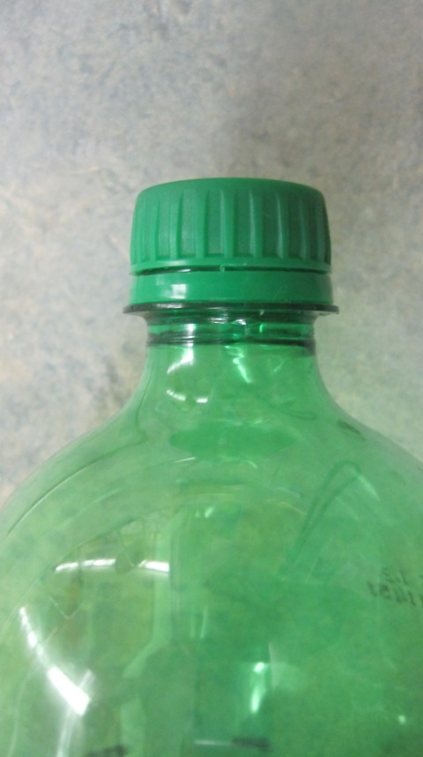

- Take the X-acto knife and put a hole into the bottle that is perpendicular to the bottle.
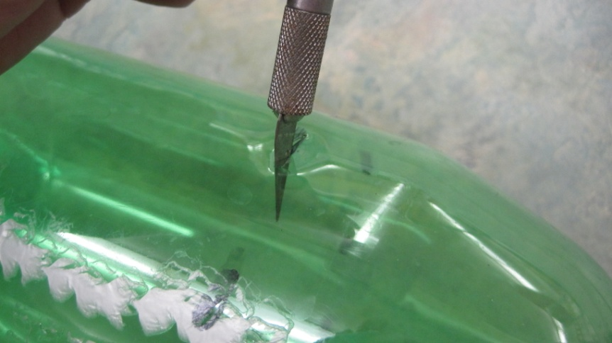

- Take the scissors and insert them into the hole and begin cutting the top off the bottle. Use your lines as a guide where to cut.
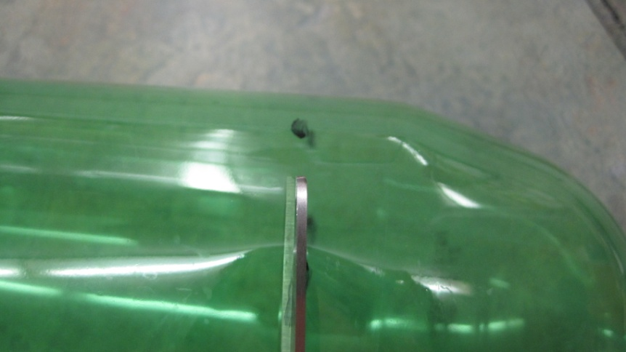

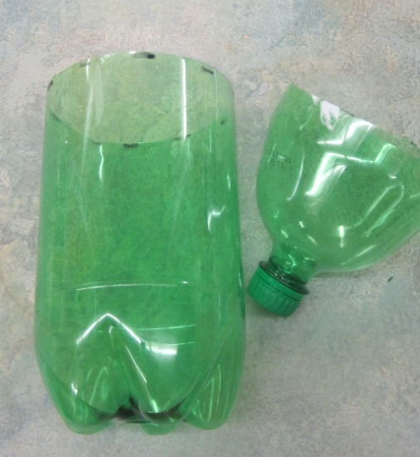

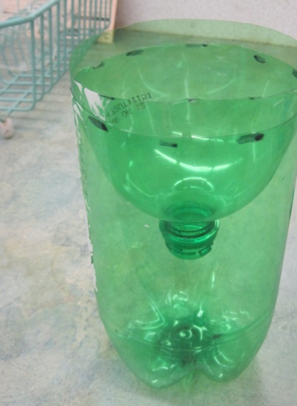

- Roll out at least 24” (24 inches) of paper towel and cut it off the roll.
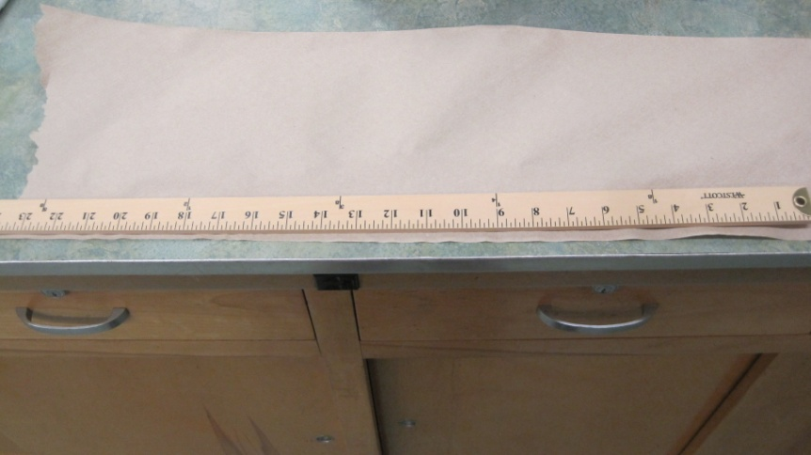

- Fold the paper towel over on itself at ¾” widths. Repeat until the towel is entirely folded on itself
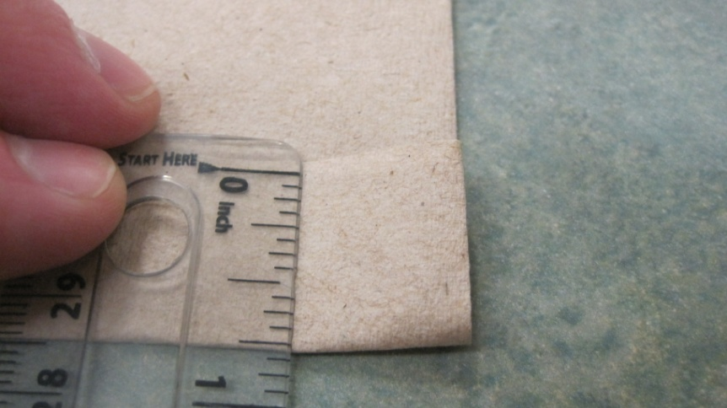

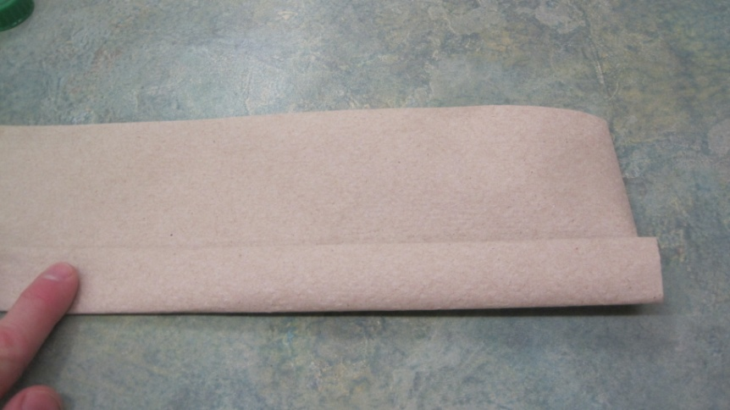

- Fold the paper towel in half to make a loop
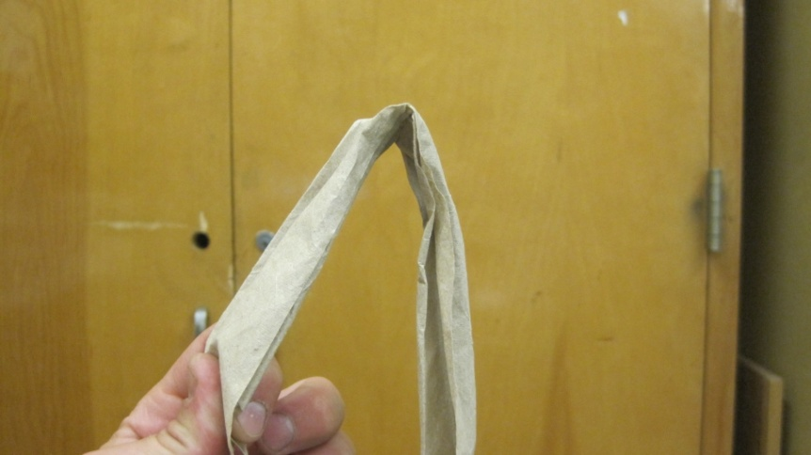

- Insert the paper towel into the top of the bottle with it folded in half
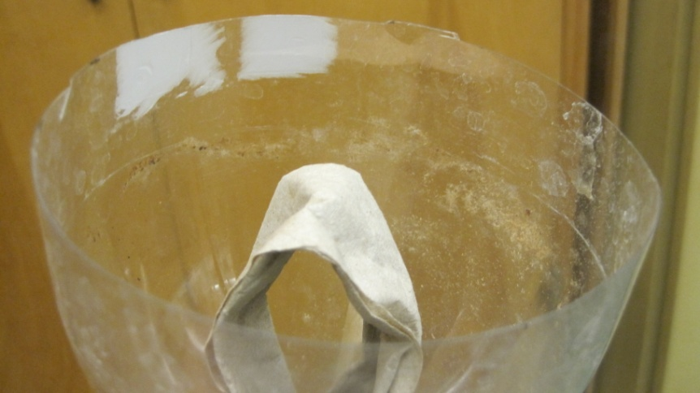

- With scissors, trim off the excess towel so that the towel just barely touches the bottom of the bottle.

- Use the extra towel to pass through the loop
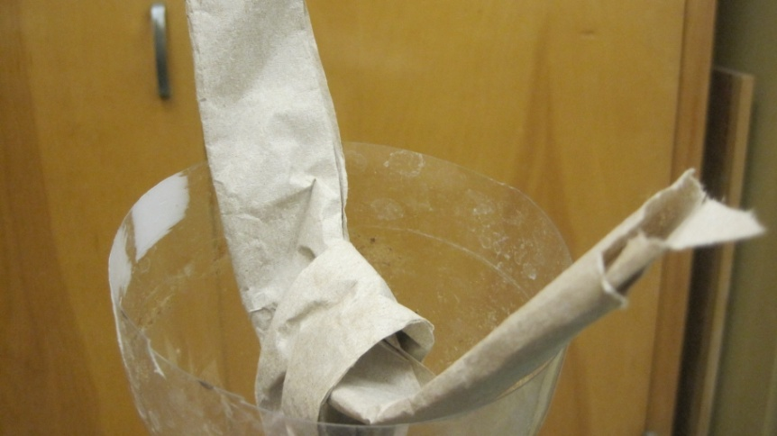

- Center the paper towel and pull it downward to the neck of the bottle
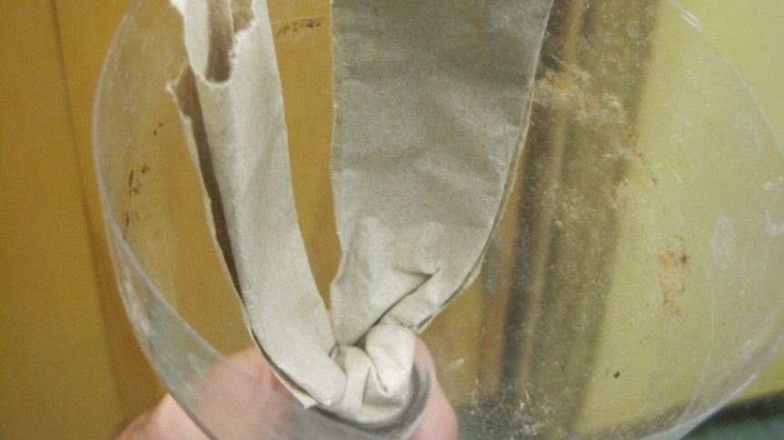

- Put 750 mL of water into the 2 liter bottle and make a ‘water line’ with a permanent marker.
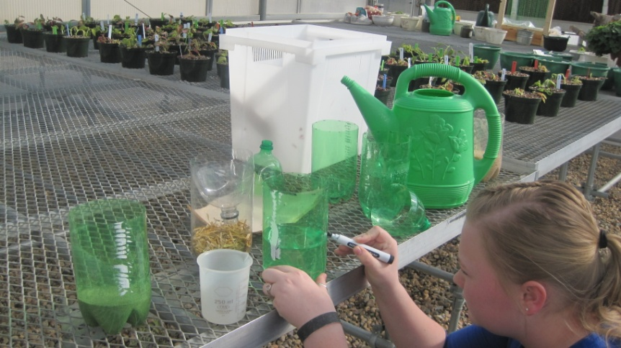

- Place 250 mL total of a soilless medium (you can use mix different quantities of multiple mediums – See attached table for ideas)
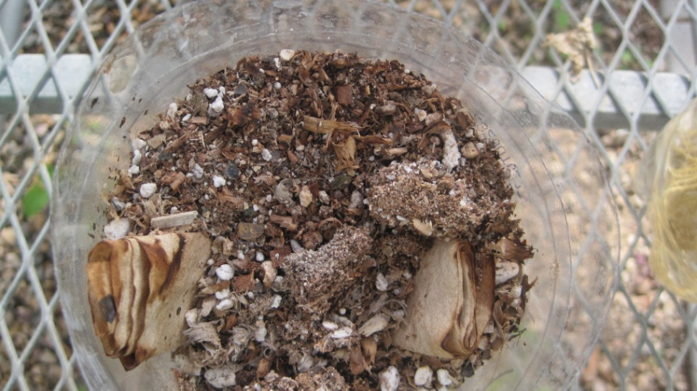

- Place the inverted bottle top into the base of the two liter
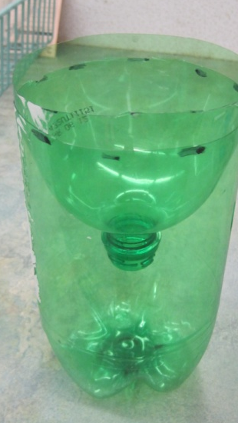

- Plant desired seeds into the medium (I have found greater success planting at a depth more shallow than the recommended)
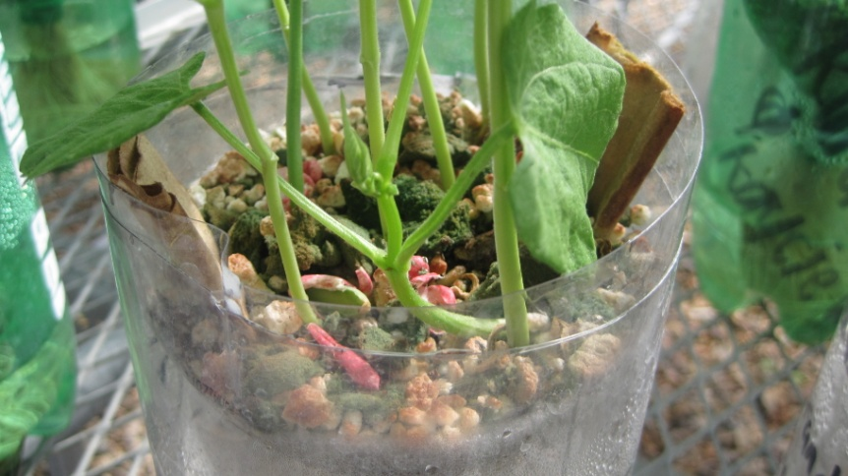

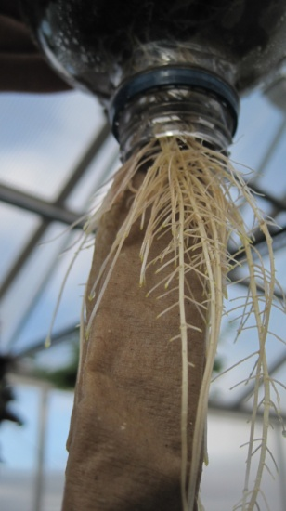

Mediums
You do not need to mix the mediums in order for this experiment to work. Mixing mediums allows students an opportunity to use laboratory equipment and test the scientific theory. Mediums I have had success are listed in the supplies section above.
All mediums are given in their quantity based upon volume (ml) because of the difference in density between the items.
Option A
 | Group 1 | Group 2 | Group 3
Floral Foam | 120 | 55 | 75
Vermiculite | 55 | 75 | 55
Pearlite | 75 | 120 | 120
TOTAL (ml) | 250 | 250 | 250
Option B
 | Group 1 | Group 2 | Group 3
Sawdust | 120 | 55 | 75
Vermiculite | 55 | 75 | 55
Pearlite | 75 | 120 | 120
TOTAL (ml) | 250 | 250 | 250

Questions
- Why does a plant need soil?
- What does a hydroponic system need to provide for a plant to survive?
- What medium(s) did you use in your system?
- What property of water is exhibited in this experiment?
- Write a ratio for the number of seeds that germinated to the number of seeds that did not germinate.

