PLANT ANATOMY, GROWTH AND DEVELOPMENT

LABORATORY EXERCISE #9--DEVELOPMENT OF SEED PARTS INTO YOUNG PLANTS

Name_______________________________________ Score ___________________________

Selection from Modern Biology, Biology Investigations, Teacher's Edition, by James H. Otto, Albert Towle, W. David Otto, and Myra E. Madnick. Copyright 1977 by Holt, Rinehart and Winston, Inc. Reprinted by permission of the publisher.

Materials needed

Dry and soaked lima beans 250-ml beaker
Dried ear of corn Paper toweling
Individual grains of corn Blotter or filter paper
Knife or single-edged razor blade Cotton
Hand lens Colored pencils
Iodine solution

Part I: A Dicot Seed--The Bean

The seed is a matured ovule and the final product of angiosperm reproduction. The new plant is provided with stored food and special coverings. Under the proper conditions vegetative growth begins. This is known as seed germination.

Obtain one dry lima bean and one that has been soaked overnight. Examine the dry seed and note its external markings. Locate a scarlike structure, the hilum.

a. What does it represent?

Locate the micropyle, a tiny opening close to the hilum.

b. What is the significance of the micropyle?

c. Would you expect all seeds to have a hilum and a micropyle?

Explain your answer.

Examine a dry seed which has been soaked overnight. Compare this seed to a dry seed.

d. What changes have occurred?

Offer an explanation for what you observe._________________________________________

_______________________________________________________________________________

Remove the thin outer seed coat, the testa.

f. Describe the cotyledons which are now visible.

g. What is their function?

Separate the cotyledons allowing the embryo plant to remain attached to one of them. The epicotyl, often called the plumule, consists of two, tiny leaves which enclose the terminal bud of the future plant. Below the epicotyl is the hypocotyl, the embryonic stem. Locate the radicle at the base of the hypocotyl. The radicle is the embryonic root. Add a drop of iodine to the testa, cotyledon, epicotyl and hypocotyl. Remember that starch turns purple or blue-black in the presence of iodine.

h. Which contains the greatest amount of starch?

i. Suggest an explanation for what you have observed.

On the figure of the external view of the bean, label: hilum, micropyle. On the figure of the internal view, label: cotyledons, epicotyl, hypocotyl, radicle.

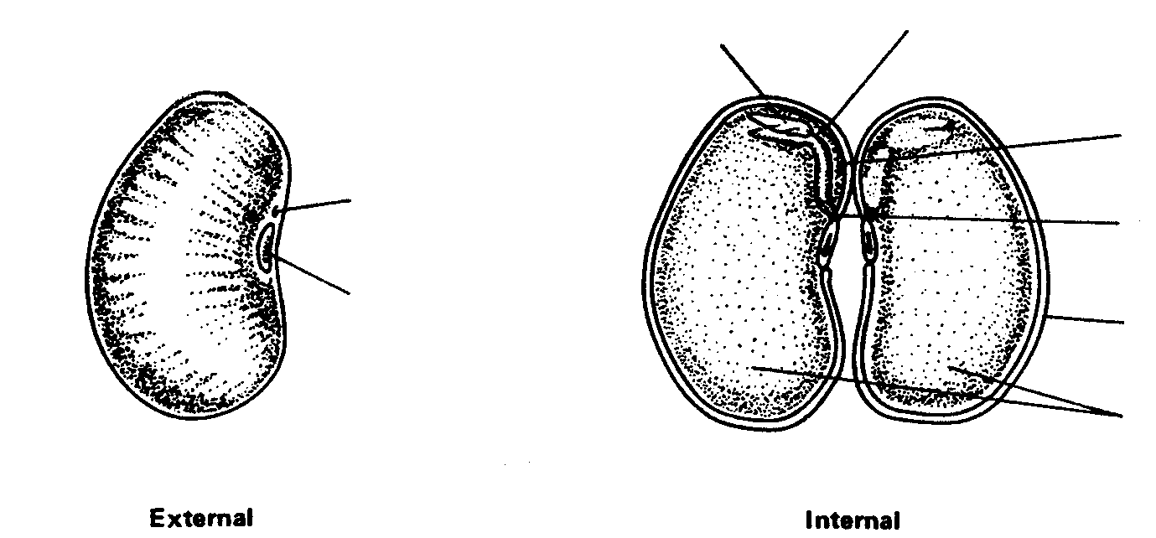

Part II: A Monocot Seed--Corn Grain

Examine an ear of corn.

a. Is this the product of a single flower or a group of flowers?

Explain your answer.

Remove a single grain. Locate the silk scar as a projection near the top of the grain.

b. Account for the location of the silk scar.

A corn silk represents a greatly elongated style ending in the stigma. It is attached to an individual ovary.

c. If an ear of corn had 250 grains, how many corn silks would there have been?

Explain your answer.

d. Would you expect of find a hilum and micropyle in the corn grain?

Explain what you are able to locate.

Locate the prominent dent on one side of the grain marking the location of the cotyledon and the embryo plant. In corn, the point of attachment corresponds to the stalk of the bean's flower. It is the pathway through which the grain receives nourishment. On the figure of the external view, label: point of attachment, silk scar.

Position a soaked kernel "dent" side up. Using a sharp razor blade, cut lengthwise at right angles to the broadside of the grain. Observe the embryo and its parts in longitudinal view. The outer covering is the ovary wall. The lower portion contains the embryo and cotyledon. The upper part of the embryo is the epicotyl sheath, directly below is the hypocotyl. The cotyledon is attached to the epicotyl and hypocotyl. The bulk of the grain is endosperm tissue which supplies food to the embryo plant. Add a drop of iodine to the endosperm.

e. What color appears?

f. In what form is food stored in the corn grain?

On the figure of the internal view, label: embryo, cotyledon, epicotyl sheath, hypocotyl, endosperm.

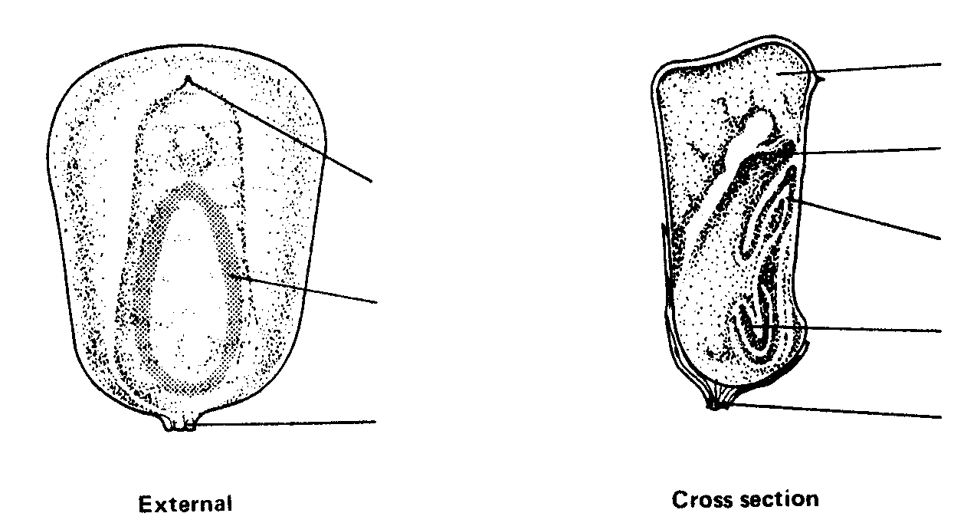

Part III: From Seed to Seedling

Prepare a germination jar by cutting a piece of blotter paper to line a 250-ml beaker. Tightly pack cotton on the inside to give support to the blotter. Place several bean seeds and corn grains in a row between the blotter and the glass about one half the distance from the top of the beaker. Moisten the cotton so that it is damp and avoid excess water. Put the beaker in a warm location. Allow the seeds to germinate until the young seedling plants are well formed. Observe the plants daily and make the following observations.

Bean Seeds: a. What embryonic structure emerges from the seed coat?

Why is this important to the seedling?

Observe the growth of the hypocotyl.

c. How does it appear?

d. Of what advantage could this be to a seedling growing in the soil?

e. Describe the position of the cotyledons.

f. As germination progresses, what becomes of the cotyledons?

Study the drawings representing stages in the germination of a bean seed. Use colored pencils to indicate each part of the embryo in the earliest stage. With the same color, shade in those structures in later stages.

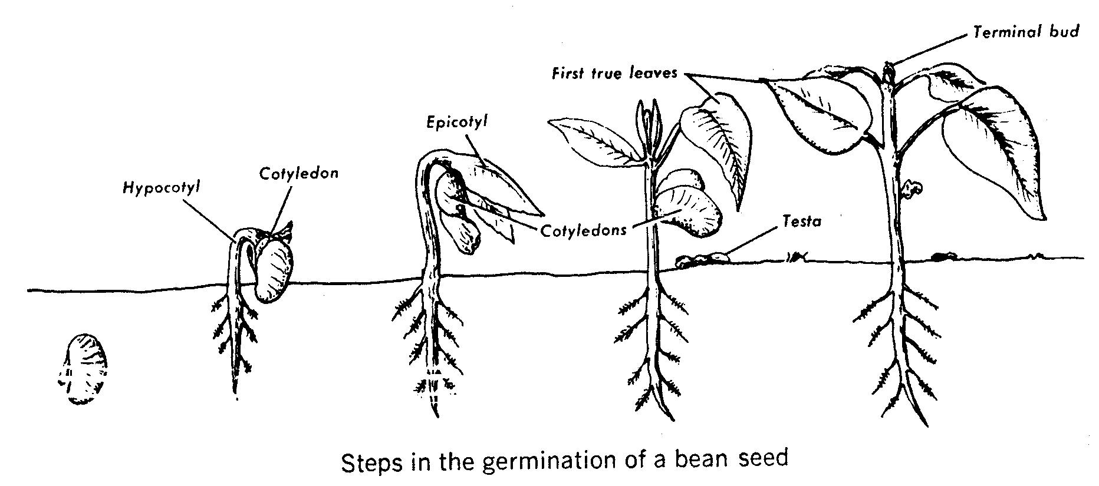

Corn Grain: Observe a germinated corn grain. Note the direction of development of the emerging root and shoot.

a. How are you able to distinguish each?

b. What type of tropism does each exhibit?

Examine a seedling that has "emerged" above ground level. Look for a colorless structure known as the epicotyl sheath, which surrounds and encloses the developing shoot. A similar structure is at the root tip.

c. What function would these structures have for the developing seedling?

d. What becomes of the epicotyl sheath as the foliage develops?

Below, use colored pencils to indicate each part of the embryo in the earliest stage. Use the same color for each structure in later stages.
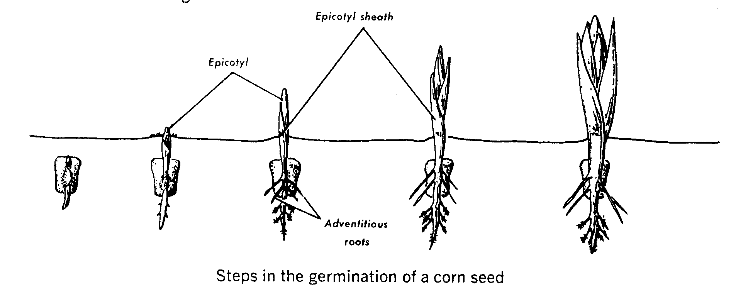

Part IV: Summary

Review what you have learned about seed structure and germination by filling in the blanks in the following statements. The answers are given at the right.

a. The ___________________of the seed becomes the first true leaves cotyledons
of the newly emerged dicot plant.
epicotyl sheath
b. The radicle of the seed becomes the _______________________
of the new seedling. epicotyl

c. The ______________________of a dicot seed supply food to radicle
the developing embryo.
hypocotyl

d. The _______________________in the bean marks the point at
which the ovule was attached to the fruit. silk scar

e. The _______________________of the corn grain contains starch. hilum

f. The point at which the pollen tube entered the embryo sac is point of attachment
marked by the ___________________________.
micropyle
g. The arching over of an emerging bean plant serves for protection
of delicate tissues. In a corn seedling this function is served primary root
by the _________________________.
endosperm
h. The _____________________________of a corn grain is likened to
the pedicel on the ovary of a bean plant.

Part V: Investigations On Your Own

Seed viability is the capability of seeds to germinate. Select 100 seeds of several species to test for their viability. Wet a piece of muslin or burlap and lay it out. Place 100 seeds of the same species in well spaced rows on the wet cloth. Wet another piece of cloth and lay it over the seeds carefully. Roll the two pieces together, loosely. This device in known as a "rag-doll tester." Prepare such a device for each species of seed. Keep the seeds moist for several days to a week. Check regularly to see if the seeds have germinated.

When germination has occurred, unroll the cloths and count the number of germinated seeds. Summarize your results in a bar graph indicating percent of seeds germinated for each species. Discuss why some seeds were unable to germinate and differences you observed when compared to the predicted viability of the seeds.

Answers to Lab#9
Lab #9

Part I:

a. The point where the seed was attached to the wall of the pod (ovary).
b. It is the opening in the ovule through which the pollen tube grew to deliver the sperm cell to the egg.
c. Yes. They must first be fertilized and then receive nourishment from the parent plant.
d. The seed has expanded and the seed coat is wrinkled.
e. Water has been absorbed.
f. The cotyledons are fleshy.
g. Food storage.
h. The cotyledons.
i. The starch will be digested by enzymes to supply glucose as food for the growing plant.
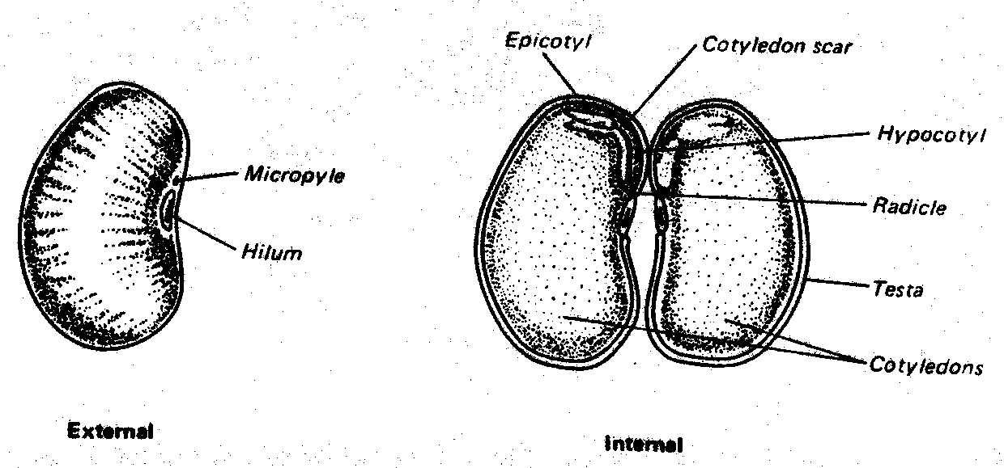

Part II:

a. A group of flowers. Each grain of corn contains a seed which is surrounded by a seed coat, the ovary wall of an individual flower.
b. It marks the point where the silk was attached to the ovule.
c. 250. For each corn grain to have matured, there must have been a silk through which the tube cell grew to accomplish fertilization.
d. Yes. They are present but not plainly visible since they are covered by a three-layered fruit coat. They are located within the point of attachment
e. Purple or blue-black.
f. Starch.

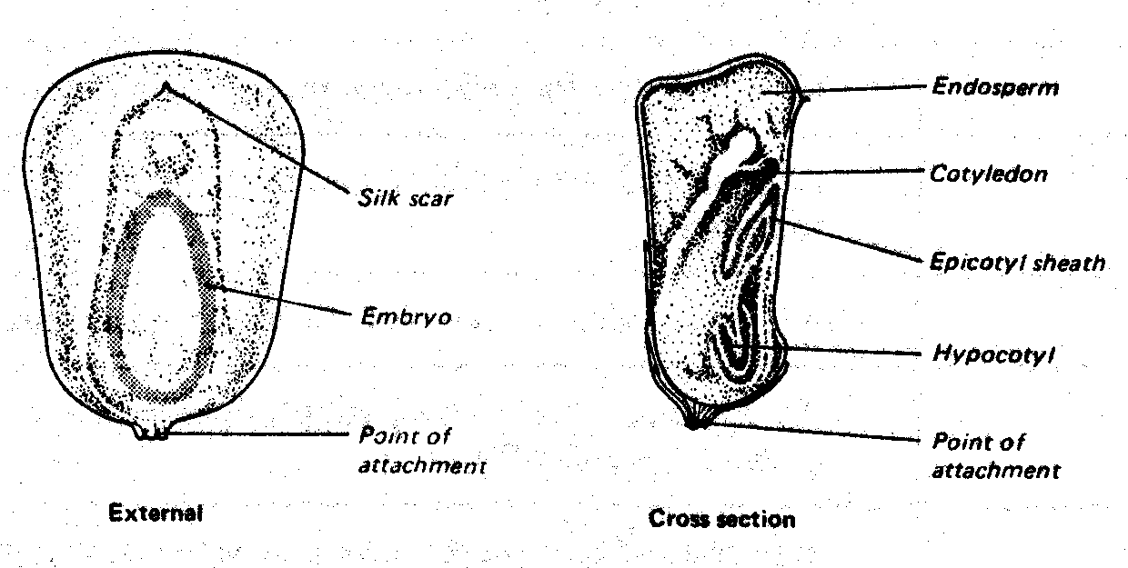

Part III:

a. The radicle (root).
b. Further development of the radicle into the primary root serves to establish a means of absorbing water.
c. It is arched or bent over.
d. It would serve to break the soil and prevent damage to the delicate leaves of the epicotyl.
e. They are attached to the hypocotyl.
f. As the plant becomes photosynthetically independent, they wither and fall off.
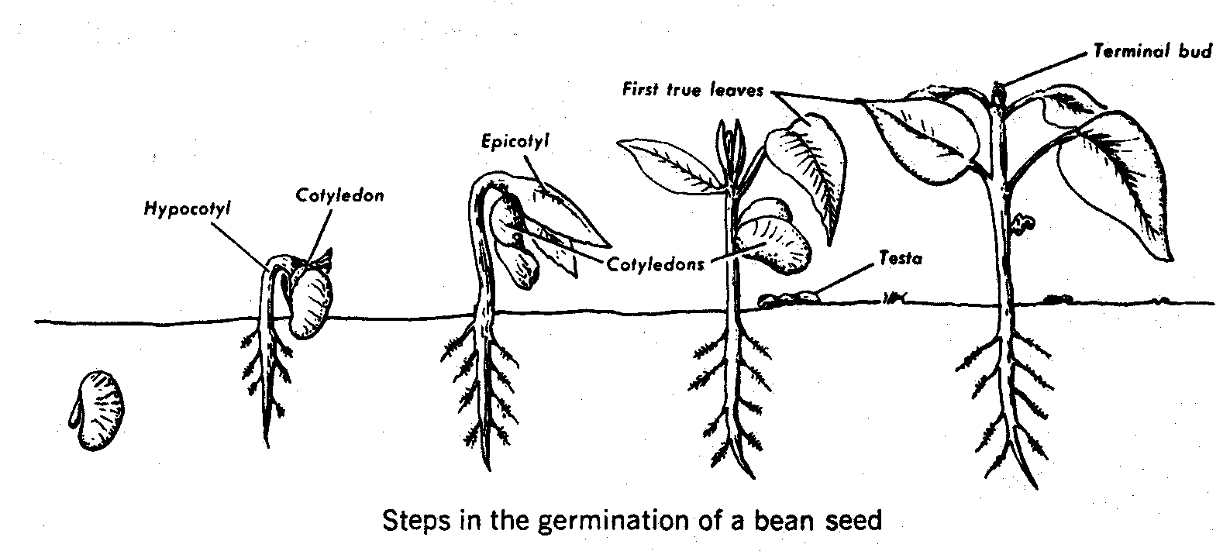

Corn Grain:

a. The shoot is growing upward and the somewhat longer root is growing downward.
b. The shoot exhibits negative geotropism and the root positive geotropism.
c. They protect the meristematic regions as growth occurs.
d. It disintegrates.

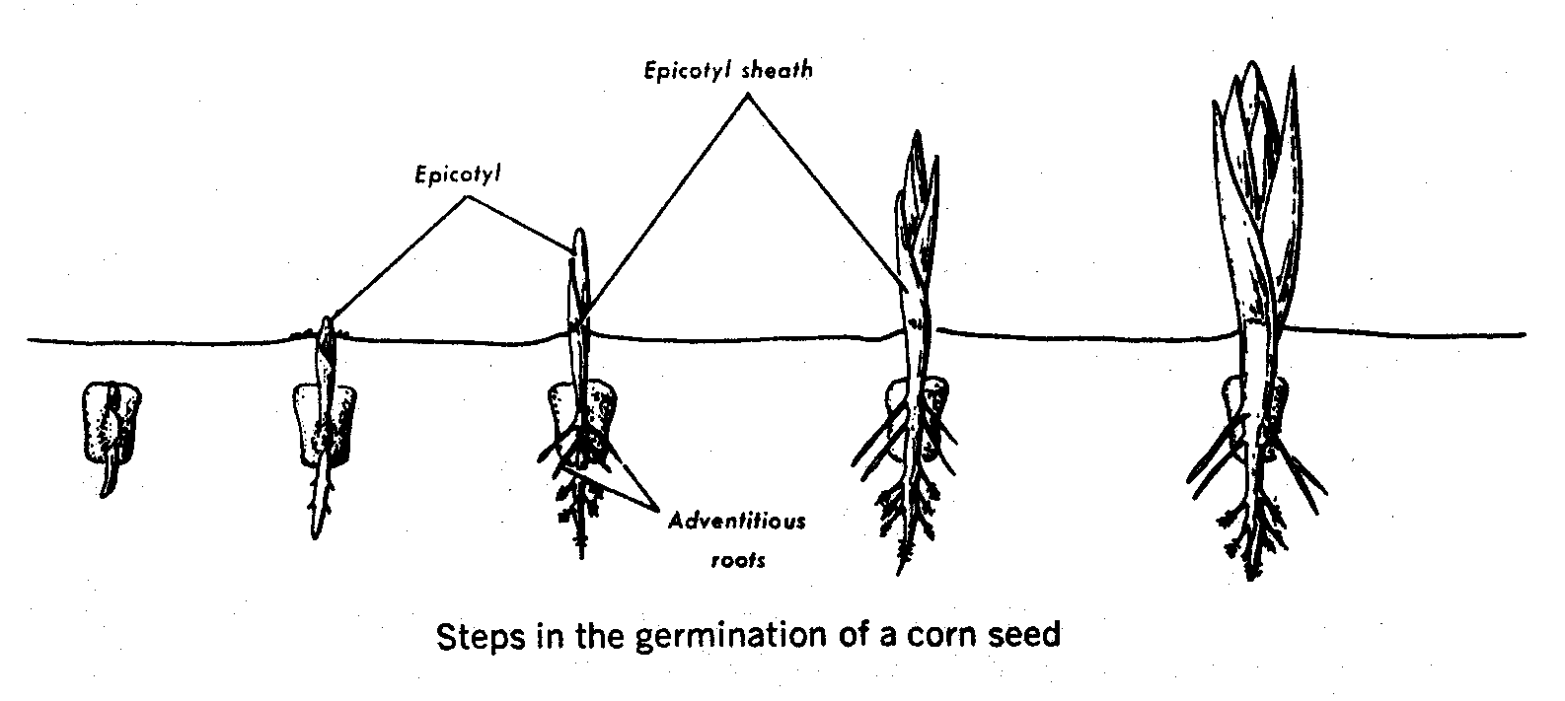

Part IV:

a. epicotyl
b. primary root
c. cotyledons
d. hilum
e. endosperm
f. micropyle
g. epicotyl sheath
h. point of attachment

