2024-2025
Westlake FFA Officer
Candidate
Handbook
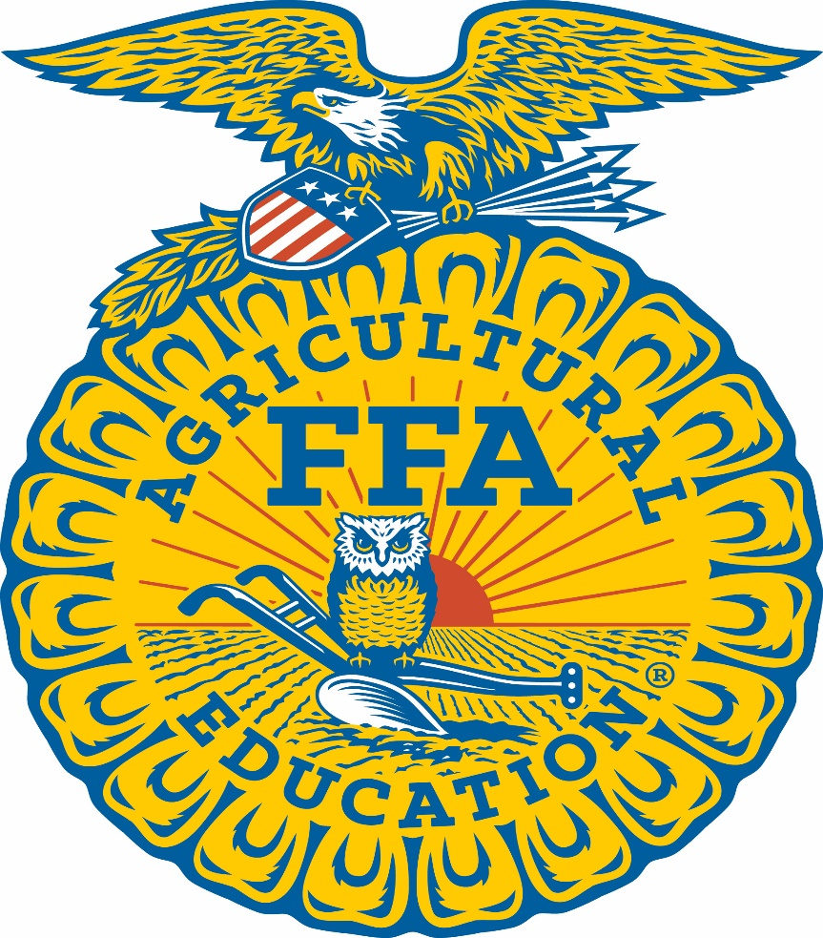

Read through this handbook in its entirety and ensure you agree and commit to all areas before filling out the application
Introduction:
Each year, members of the Westlake FFA Chapter represent the organization as a Westlake FFA Chapter Officer/Chairman. Throughout this year, these chapter officers wear a variety of hats. They are elected officials expected to represent the student membership at officer meetings, chapter meetings, student council meeting, and Career and Technical Student Organization meetings. They teach leadership and teamwork to chapter FFA leaders and FFA members. They are motivational speakers who inspire FFA members. They are communicators and public relations specialists for FFA, building positive relationships across the community. They are teammates to each other and to their advisors. They are learners, eager to grow and fulfill their responsibilities. Selecting the best candidates, as defined by the constitution and bylaws, is a challenging task for the selection committee. To facilitate this committee’s success in accomplishing the organization’s goals, a process exists – the Westlake FFA Officer Selection process. This handbook details that process.
All of the information is valuable and we encourage current candidates and parents to give everything careful consideration.
2024-2025 Westlake FFA Officer Selection Process and Timeline
May 10, 2024 (Friday) – Completed application and signed agreements returned to Mr. Gowans, by 11:59 PM Please email applications (mgowans@alpinedistrict.org) (Late application will not be accepted without consent from all advisor’s) available at WestlakeFFA.com
TBD – 7:15 AM Attend a Morning meeting in the room B125. Possible FFA Knowledge Test, Chapter Officer Candidate Orientation, sign up for interview times and receive topic for presentations.
May 13, 2024 – 2:30 AM – Interviews and Presentations after school.
- Candidates will sign up for interview order on May 2nd
- Candidates must be in full official dress (no exceptions)
May 15, 2024 – 7:00 PM at the FFA Banquet – Announcement of officers. All officer candidates must attend.
TBD – NEW Officers and Parent Meeting.
-Selection of next year’s officers will be made by a Student/Community selection committee. Congratulations, on your decision to run to be a Westlake FFA Chapter Officer. This position is a rewarding experience that requires a lot out of time, commitment, and dedication. Below are the qualifications and prerequisites to run for office.

QUALIFICATIONS AND PREREQUISITES
To participate in the Westlake FFA Chapter Officer Program, officer candidates must meet all of the eligibility requirements:
• Have and maintain a 3.00 GPA or higher for officer’s, 2.75 GPA for Chairman
• Must enroll in an Agricultural Education Course, after being elected officer and chairman should try and be in A3 for the leadership class.
• Must turn in a completed application with all signatures by the deadline.
• Must attend ALL morning officer meetings on time as listed on the schedule.
• Must have earned at least the Greenhand FFA Degree.
• Must be a member in good standing as outlined in the FFA Code of Ethics found in the Official FFA Manual and determined by the FFA Advisor(s).
• Must participate in the presentation(s) and interview in full Official Dress as outlined in the Official FFA Manual.
• Have a record book in the AET record book system.
• Take the FFA General Knowledge Test
• Have and maintain a clean discipline and attendance record.
• Attend the summer Chapter Officer Retreat and State COLT Training.
The Job of Being and Chapter Officer
The primary responsibility of a chapter officer is to serve. When you become a chapter officer, you agree to dedicate one year of your life to service with the chapter. Your year of service as a chapter officer is one of profound growth—you will change in ways you never imagined. This may be the greatest personal benefit of serving as chapter officer, along with knowing that you alone make a positive difference in the lives of FFA members, advisors, partners, community leaders, and others.

If elected to serve the chapter as a chapter officer, a great deal will be expected of you. We understand that your life is full of family, church, work, and school activities. There will be little time left to call your own. Coming early and leaving last at activities is part of being an officer. It will be a challenging year full of joys and discomforts—with the joys far outweighing the discomforts. Decide now if you are up for this challenge. If you would rather focus on yourself instead on the lives of the chapter members, chapter office is not going to be a good fit for you.
Chapter Officer Job Description
Being elected to chapter FFA office is making a commitment to service that is unique to most student organizations. In addition to serving and representing more than 175 FFA members, you will represent the image and direction of the organization to teachers, administration, school board members, agriculture leaders, parents, and the general public. You will also be a teammate to other officers and advisors.

There are eight key roles chapter officer play. Those who commit their time, energies and passions toward learning, living and modeling these eight keys of success will not only successfully complete their term of service, they will move toward excellence professionally. The following is a summary of each of the eight keys, along with already established procedures that will help you achieve success.

BE THE BRAND
Chapter FFA officers are committed to representing and upholding the FFA brand. This includes communicating the FFA brand, vision and strategic plan to others as well as communicating key organizational messages (agricultural education, supervised agricultural experiences (SAEs), FFA, youth issues and agriculture). This requires the officer to be in his or her role 24 hours a day, seven days a week for 365 days. As part of the FFA brand, there will be general rules of behavior to follow, including projecting a professional image, using proper etiquette, interacting positively with the leaders and promoting diversity.
1. Be dedicated and committed to FFA and the total program of education in agriculture/agribusiness.
2. Forego all alcohol, tobacco and illegal substances while participating in FFA.
3. Avoid places or activities that in any way would raise questions as to one’s moral character or conduct.
4. Use wholesome and appropriate language in all speeches and informal conversations.
5. Maintain proper dress and good grooming for all occasions.
6. Be willing to take and follow instructions as directed by those responsible for Chapter FFA officers.

BALANCING ACT
A Chapter FFA Officer must also include personal health, wellness and stress management as a key to success. A chapter officer committed to this will position themselves to fully serve FFA members. Included in this key commitment are flexibility/adaptability; personal reflection and growth; maintaining relationships with family and friends; keeping a realistic view of self; and preparing to transition back after your year of service.
1. Maintain and protect your health.
2. Regularly, and on time, write all letters, thank-you notes, emails and other correspondence, which are necessary and desirable.
THIS IS IT
The training and experiences in this area center around life- and time-management. An officer should excel in these areas, so that he or she will be better able to give his or her full concentration and focus to the present. This includes:
• Logistics Management (use of computer and technology, appropriate management of activities, appropriate use of chapter funds, completing paperwork properly and submitting on time and excellent communication with teammates and advisors).
• Meeting Management (creating and following agendas, consensus building, bringing people back to task and keeping focus).
• Life Management (prioritizing, meeting deadlines and timeliness).
• Financial Management (maintaining your chapter finances, understanding and following program budgets).
• Focus (listening and bridging — connecting conversation topics to FFA key messages/programs).
• Team (understanding roles on team, following the team code of ethics, following the team mission and following the team vision).
1. Be willing to commit the entire year to chapter officer activities.
2. Be willing able to serve the Westlake FFA Chapter.
3. Consider FFA officer activities to be you primary responsibility.

LIVE ABOVE THE LINE
This key focuses on virtues and behavioral characteristics that should be associated with a national officer. These include responsibility, integrity, keeping promises, speaking with purpose (communicate in a positive, honest and direct way), dealing in a constructive way with difficult people/teammates and seeking win-win solutions.
1. Evaluate, periodically, your personality and attitudes, making every effort to improve yourself.
2. Serve as a member of the team, always maintaining a cooperative attitude.
3. Work in harmony with fellow FFA officers and advisors.
4. Do not willingly engage in conversations detrimental to others.
Officer Experience At-a-Glance:
- Chapter Banquet May 1 Day
- Westlake Officer Retreat June/July 1 Day
- Utah FFA C.O.L.T. July 1 Day
- Opening Social September 1 Day
- Greenhand Week October 5 Days
- National FFA Week January 5 Days
- Recruiting April 1 Day
- Banquet May 2 Days
- MISC Monthly Activities/Meetings 12 Days
- Fundraisers Multiple Days
- Officer Meetings 25+
FFA Contests and Activities:
- Summer Activities and Tours June/July/August 2-8 Days
- Snow College Judging October 1 Day
- Utah Leadership Conference December 2 Days
- Area Contests January 1 Day
- State Convention March 3 Days
- Tooele Judging April 1 Day
- State Career Development Events April 3 Days

Officer Uniform and Other Supplies
Items to be supplied by each FFA Officer/Chairman
- Complete OFFICIAL DRESS
- FFA Jacket
- FFA tie/Scarf
- Black dress pants (Boys)/ Black Skirt (Girls)
- White collard button-up shirt
- Black dress shoes

Chapter Officer Commitment Form
The following items are commitments required of all national FFA officers.
1. Be dedicated and committed to FFA and the total program of education in agriculture/agribusiness.
2. Forego all alcohol, tobacco and illegal substances at all FFA time.
3. Avoid places or activities that in any way would raise questions as to one’s moral character or conduct.
4. Use wholesome and appropriate language in all speeches and informal conversations.
5. Maintain proper dress and good grooming for all occasions.
6. Be willing to take and follow instructions as directed by those responsible for national FFA officers and state and national FFA programs.
7. Maintain and protect my health.
8. Regularly, and on time, write all letters, thank-you notes, emails and other correspondence which are necessary and desirable.
9. Accept and seek out constructive criticism and evaluation of my total performance.
10. Through preparation and practice, develop myself into an effective public speaker and project a desirable image of FFA at all times.
11. Be willing to commit the entire year to chapter officer activities.
12. Be willing and able to travel while serving the Westlake FFA Organization.
13. Consider FFA officer activities to be my primary responsibility.
14. Strive to improve my ability to carry on meaningful and enjoyable conversations with individuals of all ages and walks of life.
15. Treat all FFA members equally by not favoring one over another.
16. Conduct myself in a manner that commands respect without any display of superiority.
17. Maintain my dignity while being personable, concerned and interested in contacts with others. Periodically evaluate my personality and attitudes making every effort to improve myself.
18. Serve as a member of the team, always maintaining a cooperative attitude.
19. Work in harmony with fellow FFA officers, and not knowingly engage in conversations detrimental to other FFA members, officers and adults.
20. Become knowledgeable of agriculture, of education in agriculture/agribusiness and of FFA. Keep myself up to date on current events.

I have read, studied and understand the intent and spirit of the items listed above. I have also read and understand the job description. If elected to office I commit to following the rules and procedures outlined. I recognize that breaking policies or these rules may result in limitations being set on my roles as a chapter FFA officer and/or the possible removal from office by the FFA Executive Committee.
Candidate Signature:
Parent Signature:
Congratulations, on running for Chapter Officer. By filling out the Westlake FFA Officer Application and signing it you are committing to all areas found in this handbook.

